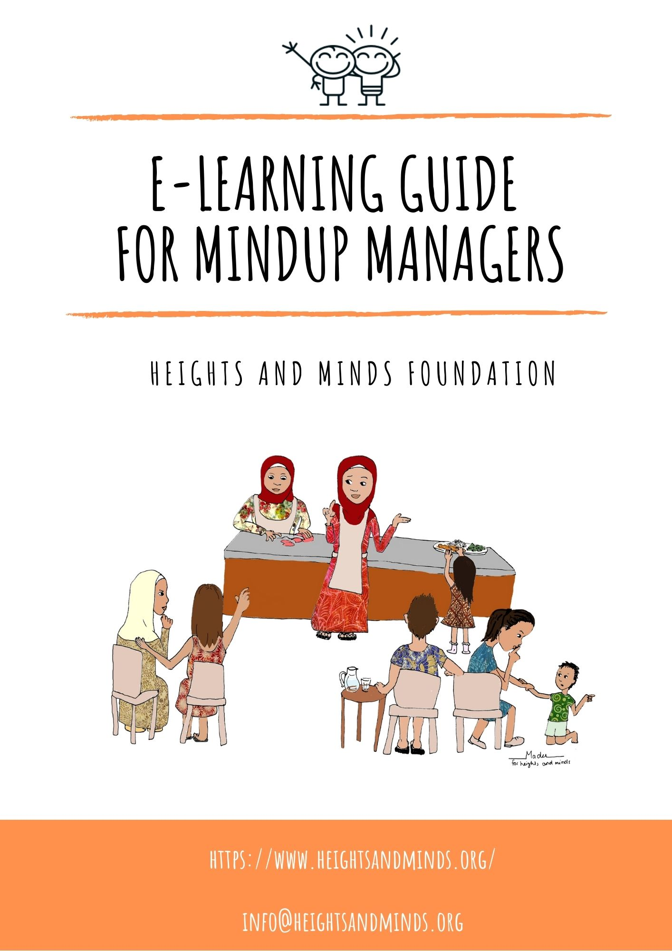

Table of content
1. Introduction 4
1.1 Why E-learning? 4
1.2 How does it work? 4
2. Methodology 5
2.1 How to use the E-learning modules 5
2.1.1 Adapting the E-learning modules to the local context and culture 5
2.1.2 Requirements of a MUM to start the E-learning training 7
2.2 Content E-learning modules 7
2.3 Sequence E-learning modules 9
2.4 Evaluation skills and knowledge E-learning modules 10
3. Media used in e-learning modules 11
3.1 Overview of GloCal videos used in e-learning modules 11
Appendix A: Terms of reference 12
Appendix B: Example of different E-learning module levels and evaluation questions 13
Appendix C: GloCal videos with links to YouTube 15

Abbreviations
ECD Early Childhood Development
GMP Growth Monitoring and Promotion
HMF Heights and Minds Foundation
MUM MindUp Manager
PPT PowerPoint
WHO World Health Organization
UNICEF United Nations Children’s Fund

Introduction
The Heights and Minds Foundation (HMF) designed an E-learning training specifically for MindUp-Managers (MUMs). This training includes technical, practical and operational modules relevant to managing the MindUps services such as child growth promotion, advice concerning nutrition and a healthy diet, and basic management of a MindUp. All modules will be in E-learning mode and will be accompanied by brief assessments to verify skills and eventual certification. Practical skills, such as for example measuring children’s height correctly, will be assessed using video calling or on-site supervision visits. All Modules and guidance notes will be adapted to the local context during the preparation phase before a MindUp opens. This is done in partnership with the local partner.

Why E-learning?
The HMF proposes E-learning because it will be the principal interactive tool to communicate with all MUMs and engage among ourselves and learn from each other. This dynamic environment is necessary to adopt to the local conditions making sure the propose method is realistic, feasible and efficient. Moreover, digital skills belong to the 21th century and we believe this method of learning will bring the MUMs up to speed with latest technology, thus opening access to the global community of practitioners in the area of nutrition. Finally, E-learning and verification of skills will allow for rapid scaling up.

How does it work?
A MUM who is responsible for a HMF MindUp has access to the provided technology, materials and tools at the MindUp and will be given an account with a password to access the E-learning modules. The local partner and HMF provide continuous guidance during the MUMs either during face-to-face sessions and or virtual sessions. MUMs will be required to take the HMF modules at the beginning of their assignments (within the first months) and there will be regular repeat training sent to MUMs in which new materials, updates and new training releases will be included. The repeat training is mandatory and there will be clear guidelines on timing with each repeat training.
The responsibilities of the MUMs include the use of digital tools and materials and it includes practical skills in addition to the training package content to fulfill their role at the MindUp. The E-learning training plan module structure is based on the MUM responsibilities such as on-line registration of new children and pregnant women, measuring children and counseling mothers and caretakers on growth, nutrition and parenting. He/she uses the digital materials available, practice skills on use of this are included in the modules.
The MUM registers pregnant women and children under the age of 2 in the HMF online registry system and starts a HMF first 1,000 days album for each new participant. The MUM measures the children under the age of 2 using the length mat every 3 months and weighs children using the salter scale every month up to the age of 2. The information is registered in the line registry.
The MUM is also expected to take on the daily management of the MindUp, so relevant basic skills in management, keeping budget and accounts, and financial reporting and entrepreneurship are required as well. The modules are tailor-made to acquire these skills rare also included in this E-learning plan.

Methodology
This chapter describes how the E-learning modules should be used, the content and sequence of the modules, and how to evaluate the skills and knowledge of the MUMs obtained by the E-learning modules.

How to use the E-learning modules
The E-learning modules are divided into 4 parts:
- Child Growth Monitoring and Promotion (GMP)
- Basic nutrition understanding
- Nutrition, Growth and Development during the first 1,000 days of life
- MindUp core management skills
The E-learning modules are available in the following languages: English, French, and Spanish and will be translated in local languages as part of the local adaptation.
These modules contain the essential skills and knowledge a MUM needs to obtain based on global guidelines from the World Health Organization (WHO) and United Nations Children’s Fund (UNICEF). All technical modules on nutrition and Early Childhood Development (ECD) will be updated by the HMF on a regular basis but at least once a year with relevant and new information. Repeat taking of the modules will be required at least once a year but may be more often following important additions and changes.

2.1.1 Adapting the E-learning modules to the local context and culture
To adapt the E-learning modules to the local context and culture, the HMF needs support from partner organizations in the host country of the MindUp. The adaptation will be done as part of the preparation phase during which the MindUp is being established and MUMs are selected.
Adapting the E-learning modules to the local context and culture requires:
(i) verifying the content of the e-learning modules with the national guidelines of the host country,
(ii) translating the content of the modules to the local language,
(iii) adapting examples of foods given in the modules to locally available and affordable foods, and
(iv) adjusting to certain cultural beliefs towards nutrition or health advice given in the E-learning modules.
In all of the E-learning modules text / pictures / videos / guidelines that can/should be adapted to the local context, are marked with an asterix * At the end of each E-learning module, specific guidance is included as to which text/video etc requires local adaptation to the local context and whether it is a global nutrition guideline that can be adapted to the national nutrition guidelines, pictures with examples of foods, educative/explanatory videos. An example of this is given in figure 1.
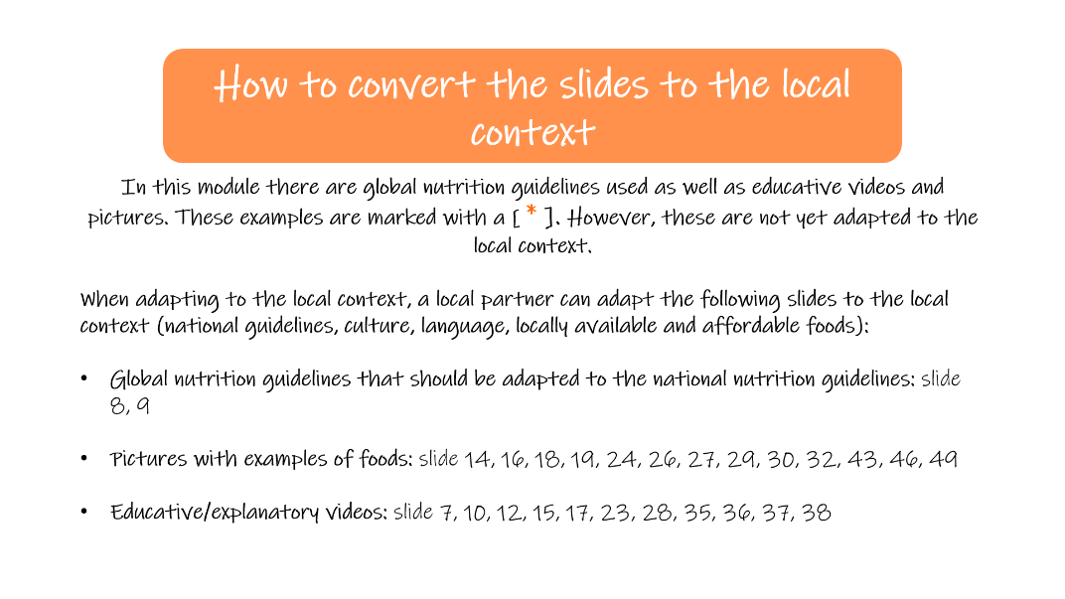
Figure 1 Example of an explanation on how to convert the slides to the local context at the end of the complementary feeding module
Example of how to convert a slide to the local context
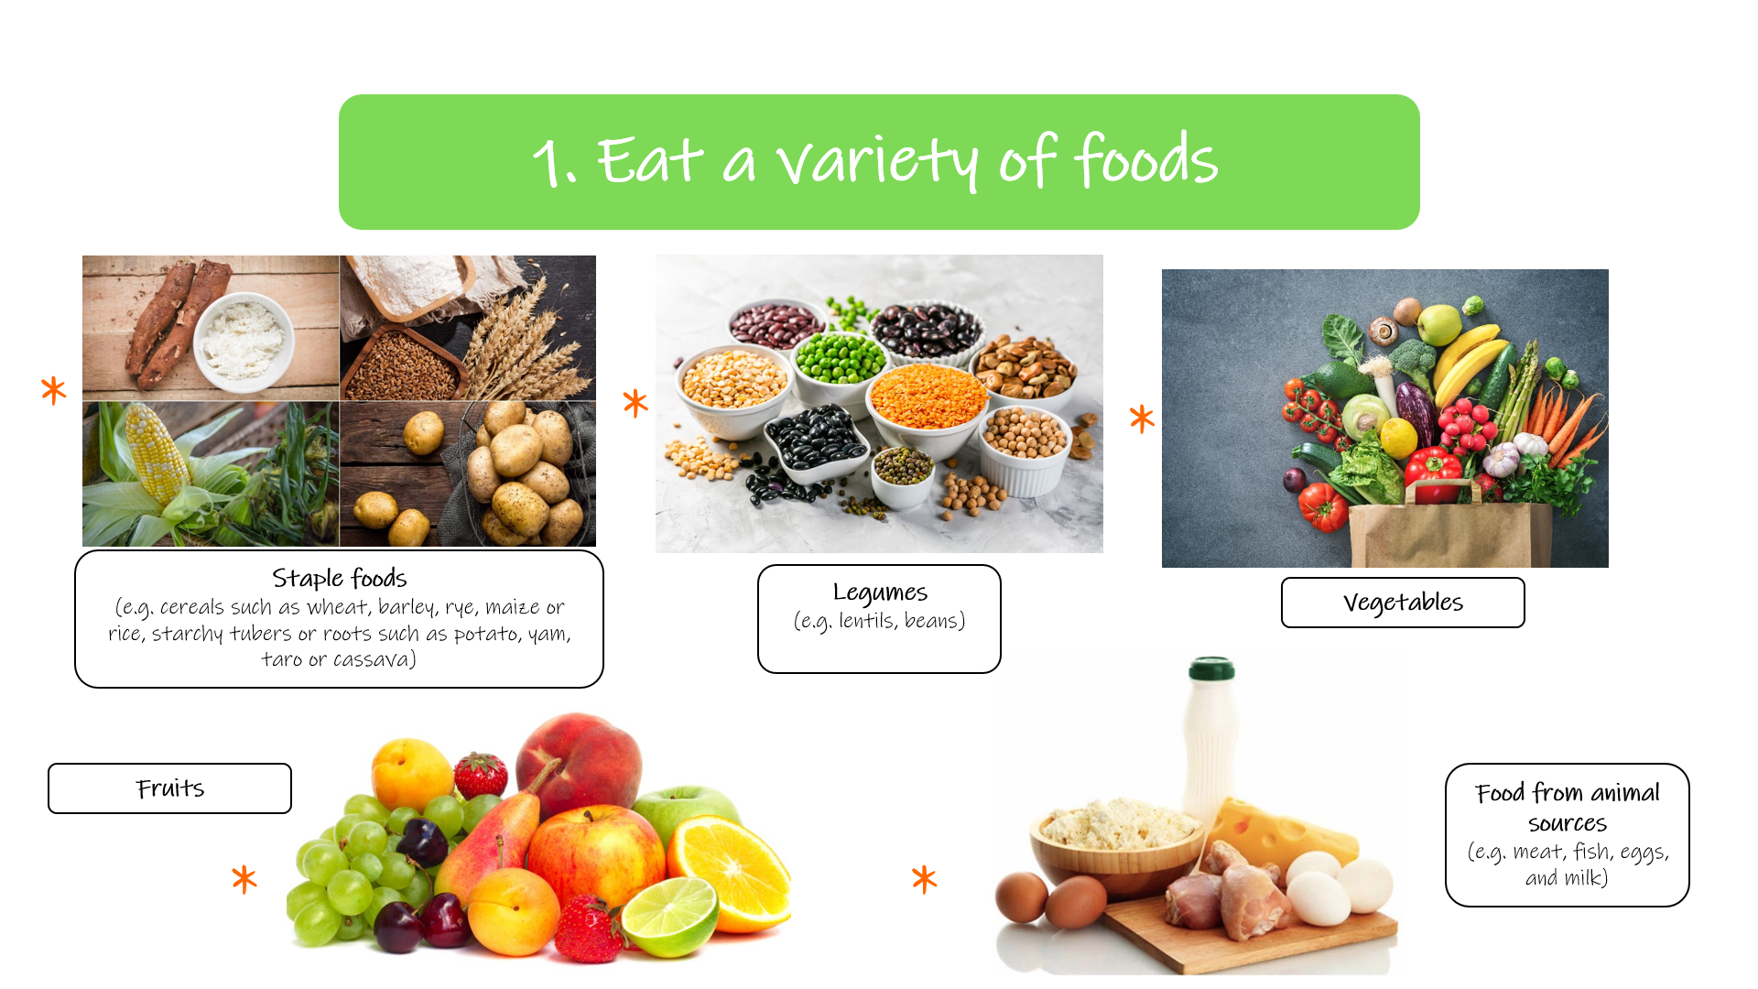
Figure 2 Example of a slide from the complementary feeding module that can be adapted to the local context by the local partner organization.
Figure 2 can be adapted to the local context by replacing the pictures of staple foods, legumes, vegetables, fruits, and animal foods by pictures of foods in these food groups that are locally available, affordable and accessible. Examples can be written down in the description of the 5 different food groups.
When needed the text can be translated by the local partner organization to the local language of the host country of the HMF MindUp also.

2.1.2 Requirements of a MUM to start the E-learning training
After adapting the E-learning modules to the local context and culture, a MUM can take the E-learning training if he/she meets the following requirements:
- Willingness to learn and to engage
- Have access to Mobile phone number and/or e-mail address
- Basic computer skills and the ability to work with Microsoft office (Word, Excel and PowerPoint)
- Basic Understanding of English, French or Spanish is preferred

Content E-learning modules
The E-learning modules are divided in 4 parts and subdivided in different modules. The content is described in the following tables.
- Child Growth Monitoring and Promotion (GMP)
Themes | Modules | Materials
Child Growth Monitoring and Promotion | GMP | E-learning module (PPT format) – includes the following subjects:  - Malnutrition  - Stunting  - First 1,000 days  - GMP (measurements, interpretation)  - Developmental milestones  Also includes an instruction video on how to perform anthropometrical measurements in French/Bahasa.

- Basic nutrition understanding
Themes | Modules | Materials
Basic nutrition understanding | - Healthy diet, macro- and micro nutrients | E-learning module (PPT format) -  includes the following subjects:  - A healthy diet for pregnant women  - A healthy diet for adults  - A healthy diet for infants and young children  - Practical advice on maintaining a healthy diet throughout the life cycle  - Macronutrients: carbohydrates, proteins, fats  - Micronutrients: vitamins, minerals important for pregnant women / infants and young children (folate, iodine, iron, vitamin A, zinc)

- Nutrition, Growth and Development during the first 1,000 days of life
Themes | Modules | Materials
Nutrition | - Module Breastfeeding  - Module Complementary Feeding | E-learning module (PPT format) - includes the following subjects:  - The basics of breastfeeding (benefits, exclusive breastfeeding, positions, frequency)  - The benefits of breastmilk over formula and animal milk  - Attachment to the breast  - Milk expression  - Storing breastmilk  - Breastfeeding problems  - HIV and breastfeeding  E-learning module (PPT format) -includes the following subjects:  - Good complementary foods  - The introduction of complementary foods  - (Complementary) feeding  - Snacks and finger foods  - Foods to avoid during the complementary feeding phase  - HIV and complementary feeding  - Keeping food safe and clean  - Developmental readiness for complementary foods  - Adverse reactions to food  - Establishing dietary variety and food preferences
Individual counselling | - First 1,000 days messages | E-learning module (PPT format) - includes the following subjects:  Advices to give to pregnant women and parents of infants and young children every 100 days

- MindUp core management skills
Themes | Modules | Materials
MindUp Managers | - MindUp management  - Entrepreneurship  - Other (environment, sustainability, etc.) | -Drafting-  E-learning module (PPT format) -  includes the following subjects:  - Basic planning and budgeting  - Accounting and financial management  - Marketing

Sequence E-learning modules
The sequence of the E-learning modules is viewed in figure 3.
When a MUM starts the E-learning training it is best to start with the modules on growth promotion which explain the different forms of malnutrition and the importance of monitoring child growth. After that a MUM can continue with the GMP module and the modules with regard to breastfeeding, complementary feeding, and first 1,000 days messages. These modules contain the key information needed to assist young mothers, and mothers to be with monitoring the growth of their child and give the right advice. To get more basic nutrition understanding, the module about a healthy diet, macro- and micro nutrients can be studied.
Lastly, the modules about MindUp management will provide a MUM all the essential knowledge and skills to run a MindUp.

Figure 3 Sequence E-learning modules
Basic, intermediate, advanced levels E-learning modules
The E-learning modules child GMP, breastfeeding, complementary feeding, and a healthy diet: macro- and micro nutrients consist of 3 different levels: basic, intermediate, advanced². The aim for a MUM is to reach all of the three levels in order to provide all types of advice concerning a certain topic to parents of infants and young children and pregnant women.
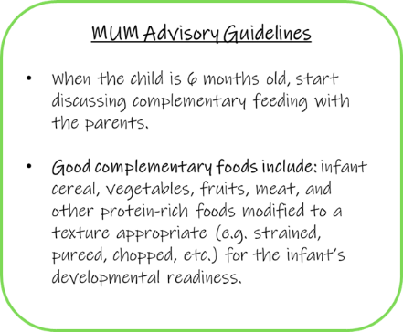
The MUM can continue to a higher level when he/she answers all of the questions from the checklist at the end of a level correctly. To successfully finish the GMP module, it is also necessary that a MUM can perform the anthropometrical measurements, interpret the outcomes, and is able to register the data.
MUM advisory guidelines
In order to have a clear link to the growth promotion messages, on various slides of the E-learning modules “Mum Advisory Guidelines” are included to highlight what information should be shared with adolescents, pregnant women, and/or parents of infants and young children during the individual counselling sessions. Figure 4 provides an example. The MUM Advisory Guidelines can also be adapted to the local context/culture by the local partner organization.
Figure 4 An example of MUM Advisory Guidelines in the complementary feeding module

²See Appendix B: Example of different E-learning module levels and evaluation questions

Evaluation skills and knowledge E-learning modules
After taking the E-learning training a MUM should have basic skills and understanding of the following subjects:
- Child GMP
- Basic principles: breastfeeding, complementary feeding
- Practical skills: measuring children’s height (using the child length mat), children’s weight, and arm circumference
- Interpretation of anthropometric measurements and reporting
- Basic communication relevant to MindUp MUM counseling
- Basic nutrition understanding
- Maintaining a healthy diet throughout the life-cycle
- Macro- and micronutrients
- Hygiene and sanitation
- Food safety handling skills
- Nutrition, Growth and Development during the first 1,000 days of life
- Breastfeeding
- Complementary feeding
- First 1,000 days messages
- MindUp core management skills
- Management (basic planning and budgeting, accounting and financial management, and marketing)
- Basically what you need to know to run a MindUp!
This will be evaluated by…

Media used in e-learning modules
The majority of the videos that we use in our E-learning modules are made by Certa Nutritio³ (existing of a team of 4 researchers from the University of Helsinki, Finland). They are a small company specialized in Nutrition Education. Their focus is mainly on the nutrition and health of children, mothers and adolescent in low- and middle income countries. The videos that they make are available on YouTube under the name “GloCal” but can also be downloaded, the content of these videos is adapted to the global guidelines of the WHO and UNICEF.

Overview of GloCal videos used in e-learning modules
There are GloCal videos made for different themes including pregnancy, delivery, breastfeeding, complementary feeding, cognitive development, disease, nutrients and healthy foods, growth monitoring and promotion, hygiene, sexual health, and kitchen garden. Some of these are included in to support the content of our e-learning modules. The GloCal videos with the YouTube links can be found in Appendix C.
Figure 5 GloCal introduction video

³Website Certa Nutritio: https://www.certanutritio.com/
Website GloCal: http://www.glocalnutrition.com/

Appendix A: Terms of reference

Appendix B: Example of different E-learning module levels and evaluation questions
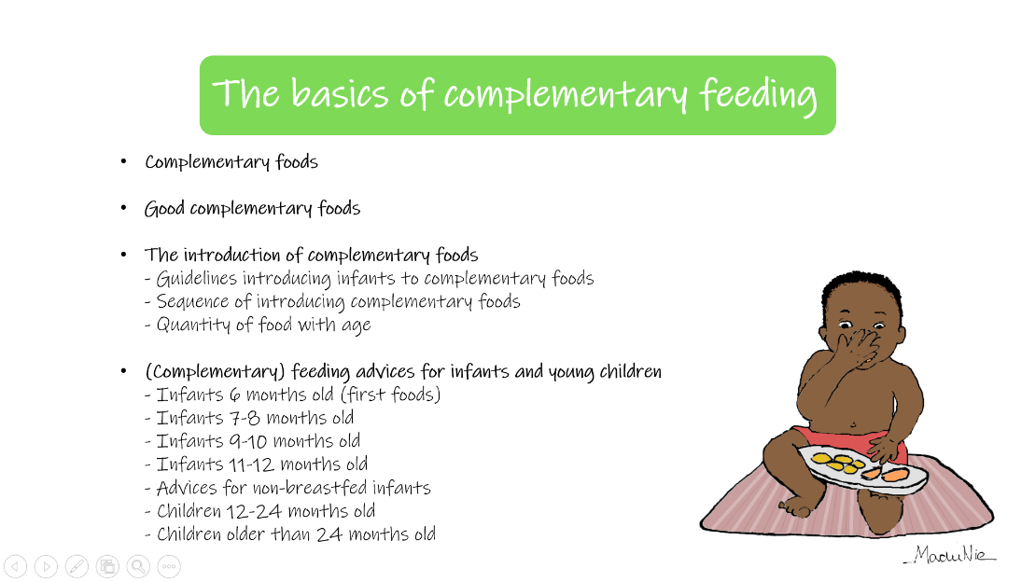
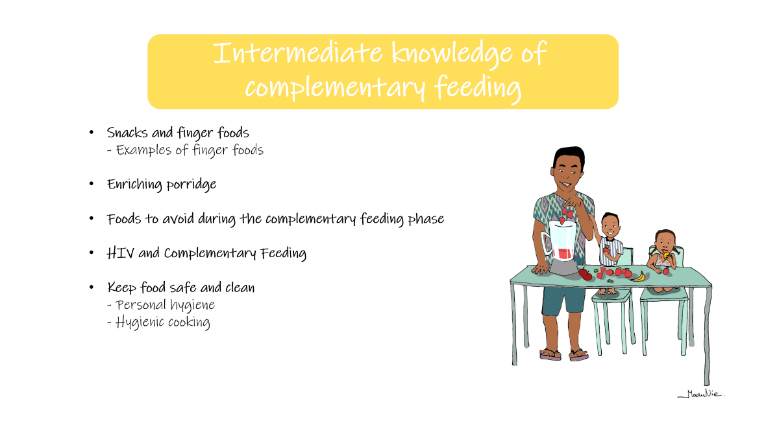
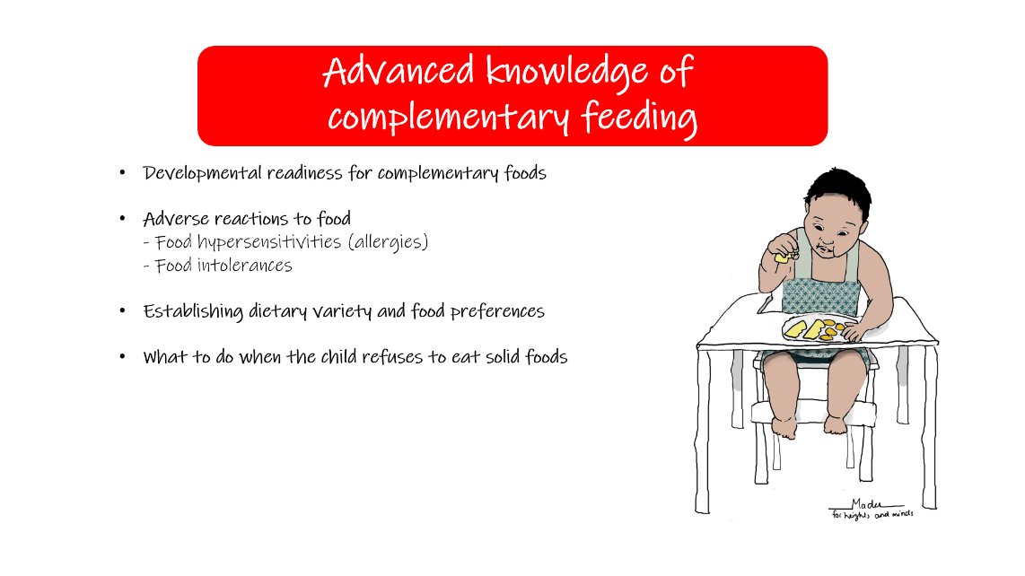
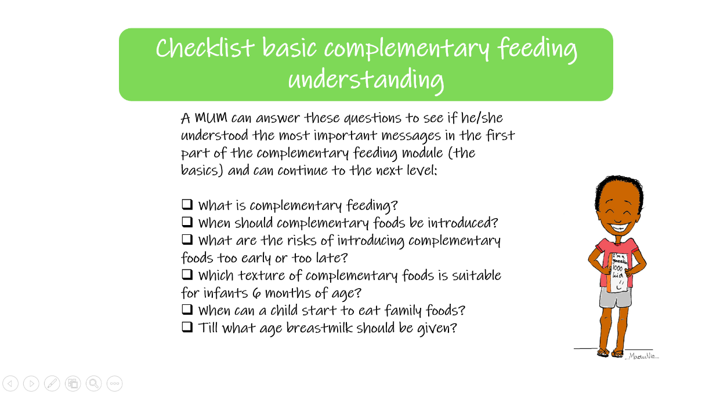
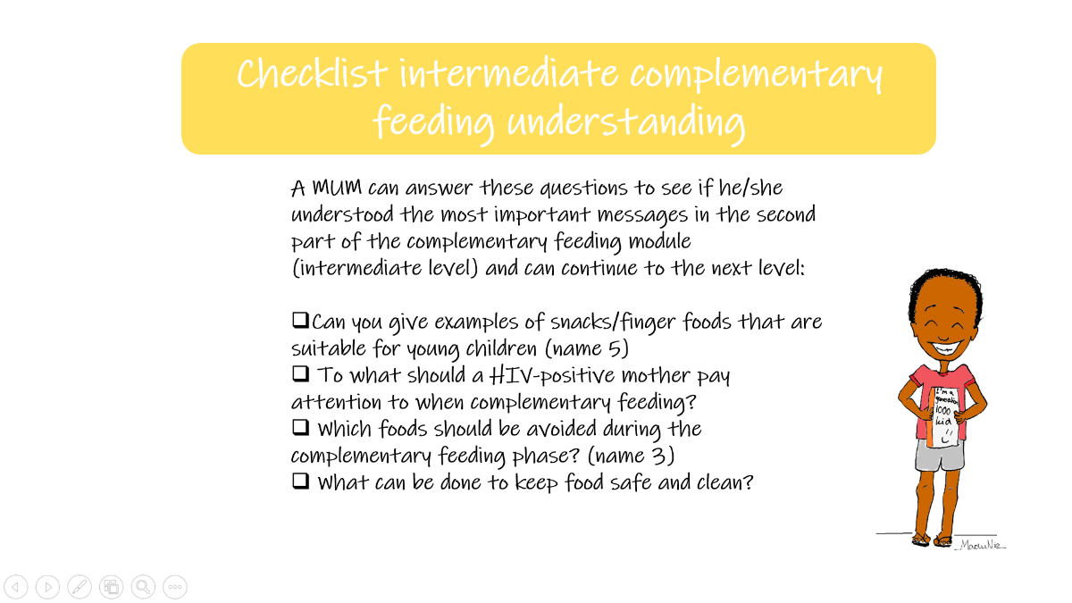
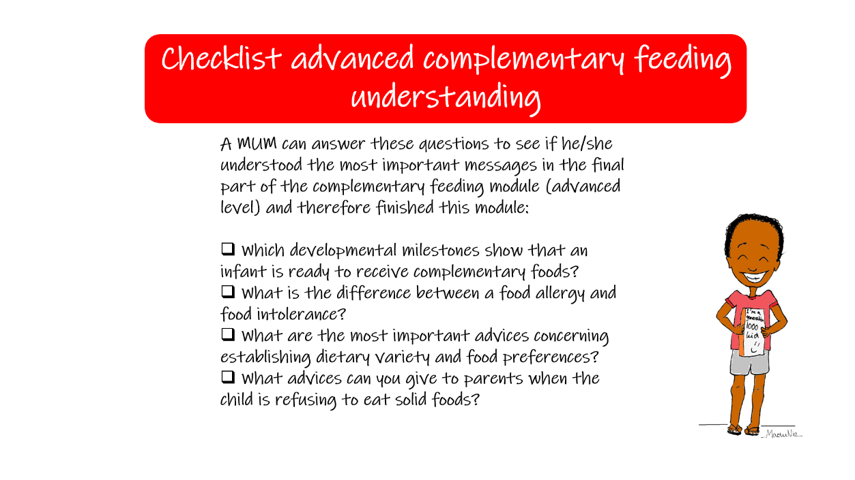
Appendix C: GloCal videos with links to YouTube
Video | English (African) | French |  | Wolof
- Quantity of food during pregnancy  - Weight gain during pregnancy | - https://www.youtube.com/watch?v=LVh6f-8frV0&list=PLOS5MMmDL-YdeY8gpi1Q8-bOqLOoHkYq_&index=31&ab_channel=CertaNutritio  - https://www.youtube.com/watch?v=mz5IiH5fK8E&list=PLOS5MMmDL-YdeY8gpi1Q8-bOqLOoHkYq_&index=42&ab_channel=CertaNutritio |  | - https://www.youtube.com/watch?v=_c70ucP4iGU&list=PLOS5MMmDL-YcVnY1BEIeOxuyFSRr01fpc&index=34&ab_channel=CertaNutritio  - https://www.youtube.com/watch?v=012_zQoqmFs&list=PLOS5MMmDL-YcVnY1BEIeOxuyFSRr01fpc&index=44&ab_channel=CertaNutritio | - https://www.youtube.com/watch?v=5Kcey6ji8gA&list=PLOS5MMmDL-YcDExF51kgu-YChnkV2a04C&index=45&ab_channel=CertaNutritio  - https://www.youtube.com/watch?v=pJfNI9swXu0&list=PLOS5MMmDL-YcDExF51kgu-YChnkV2a04C&index=61&ab_channel=CertaNutritio
- Theme: Pregnancy
- Theme: Delivery
Video | English (African) | French | Wolof
- Care after delivery  - Delivering at health care facilities  - Vaccinations  - Kangaroo care | - https://www.youtube.com/watch?v=SjK2fyk0ICA&list=PLOS5MMmDL-YdeY8gpi1Q8-bOqLOoHkYq_&index=5&ab_channel=CertaNutritio  - https://www.youtube.com/watch?v=eU0pvf_WCy4&list=PLOS5MMmDL-YdeY8gpi1Q8-bOqLOoHkYq_&index=11&ab_channel=CertaNutritio  - https://www.youtube.com/watch?v=aSon8jMOV5w&list=PLOS5MMmDL-YdeY8gpi1Q8-bOqLOoHkYq_&index=40&ab_channel=CertaNutritio  - https://www.youtube.com/watch?v=y7kgeZvhW5E&list=PLOS5MMmDL-YdeY8gpi1Q8-bOqLOoHkYq_&index=24&ab_channel=CertaNutritio | - https://www.youtube.com/watch?v=XbitbJSRjIw&list=PLOS5MMmDL-YcVnY1BEIeOxuyFSRr01fpc&index=5&ab_channel=CertaNutritio  - https://www.youtube.com/watch?v=UGnUQfRTrdo&list=PLOS5MMmDL-YcVnY1BEIeOxuyFSRr01fpc&index=12&ab_channel=CertaNutritio  - https://www.youtube.com/watch?v=C3juc4aJFoo&list=PLOS5MMmDL-YcVnY1BEIeOxuyFSRr01fpc&index=42&ab_channel=CertaNutritio  - https://www.youtube.com/watch?v=NirUPgRYZT0&list=PLOS5MMmDL-YcVnY1BEIeOxuyFSRr01fpc&index=28&ab_channel=CertaNutritio | - https://www.youtube.com/watch?v=YiAK3WRX5dA&list=PLOS5MMmDL-YcDExF51kgu-YChnkV2a04C&index=13&ab_channel=CertaNutritio  - https://www.youtube.com/watch?v=0NNFTmoMMA8&list=PLOS5MMmDL-YcDExF51kgu-YChnkV2a04C&index=20&ab_channel=CertaNutritio  - https://www.youtube.com/watch?v=l_BZUzfJ0V8&list=PLOS5MMmDL-YcDExF51kgu-YChnkV2a04C&index=57&ab_channel=CertaNutritio  - https://www.youtube.com/watch?v=Y2MZivuL1Lw&list=PLOS5MMmDL-YcDExF51kgu-YChnkV2a04C&index=38&ab_channel=CertaNutritio

- Theme: Breastfeeding
Video | English (African) | French | Wolof
- Breastfeeding benefits  - Breastfeeding position  - Breastmilk vs. Animal milk  - Colostrum  - Exclusive breastfeeding  - How often to breastfeed  - Milk expression  - Physiology of lactation  - Sufficiency of breastmilk  - Working mother  - HIV and breastfeeding  - Breastfeeding problems | - https://www.youtube.com/watch?v=bhvNFPEjMig&list=PLOS5MMmDL-YdeY8gpi1Q8-bOqLOoHkYq_&index=2&ab_channel=CertaNutritio  - https://www.youtube.com/watch?v=g_94MLpyZHE&list=PLOS5MMmDL-YdeY8gpi1Q8-bOqLOoHkYq_&index=3&ab_channel=CertaNutritio  - https://www.youtube.com/watch?v=1kiE25BgmUY&list=PLOS5MMmDL-YdeY8gpi1Q8-bOqLOoHkYq_&index=4&ab_channel=CertaNutritio  - https://www.youtube.com/watch?v=2p5O_hlh1Dk&list=PLOS5MMmDL-YdeY8gpi1Q8-bOqLOoHkYq_&index=7&ab_channel=CertaNutritio  - https://www.youtube.com/watch?v=96DNWtWKgPM&list=PLOS5MMmDL-YdeY8gpi1Q8-bOqLOoHkYq_&index=15&ab_channel=CertaNutritio  - https://www.youtube.com/watch?v=-iDhJv6Sqm0&list=PLOS5MMmDL-YdeY8gpi1Q8-bOqLOoHkYq_&index=20&ab_channel=CertaNutritio  - https://www.youtube.com/watch?v=_-eTnXlRrSo&list=PLOS5MMmDL-YdeY8gpi1Q8-bOqLOoHkYq_&index=26&ab_channel=CertaNutritio  - https://www.youtube.com/watch?v=jmI4g25eK8s&list=PLOS5MMmDL-YdeY8gpi1Q8-bOqLOoHkYq_&index=28&ab_channel=CertaNutritio  - https://www.youtube.com/watch?v=uXEodry8PqA&list=PLOS5MMmDL-YdeY8gpi1Q8-bOqLOoHkYq_&index=38&ab_channel=CertaNutritio  - https://www.youtube.com/watch?v=HFG6ZvjQ8Sw&list=PLOS5MMmDL-YdeY8gpi1Q8-bOqLOoHkYq_&index=45&ab_channel=CertaNutritio  - https://www.youtube.com/watch?v=KXO6Gco9JSc&list=PLOS5MMmDL-YdeY8gpi1Q8-bOqLOoHkYq_&index=49&ab_channel=CertaNutritio  - https://www.youtube.com/watch?v=dPpPVtO1pGU&list=PLOS5MMmDL-YdeY8gpi1Q8-bOqLOoHkYq_&index=64&ab_channel=CertaNutritio | - https://www.youtube.com/watch?v=UQiDYaTUhwA&list=PLOS5MMmDL-YcVnY1BEIeOxuyFSRr01fpc&index=2&ab_channel=CertaNutritio  - https://www.youtube.com/watch?v=iZ0VvpOsxaU&list=PLOS5MMmDL-YcVnY1BEIeOxuyFSRr01fpc&index=3&ab_channel=CertaNutritio  - https://www.youtube.com/watch?v=WJ-HQ3i5tXs&list=PLOS5MMmDL-YcVnY1BEIeOxuyFSRr01fpc&index=4&ab_channel=CertaNutritio  - https://www.youtube.com/watch?v=jJSMIJrJKKQ&list=PLOS5MMmDL-YcVnY1BEIeOxuyFSRr01fpc&index=7&ab_channel=CertaNutritio  - https://www.youtube.com/watch?v=bP_XOSRQgXg&list=PLOS5MMmDL-YcVnY1BEIeOxuyFSRr01fpc&index=16&ab_channel=CertaNutritio  - https://www.youtube.com/watch?v=Fgv22I0mT_c&list=PLOS5MMmDL-YcVnY1BEIeOxuyFSRr01fpc&index=24&ab_channel=CertaNutritio  - https://www.youtube.com/watch?v=hVyKuc_yjHo&list=PLOS5MMmDL-YcVnY1BEIeOxuyFSRr01fpc&index=57&ab_channel=CertaNutritio  - https://www.youtube.com/watch?v=EEh-vbL5B7E&list=PLOS5MMmDL-YcVnY1BEIeOxuyFSRr01fpc&index=31&ab_channel=CertaNutritio  - https://www.youtube.com/watch?v=K5RvzArnQJ8&list=PLOS5MMmDL-YcVnY1BEIeOxuyFSRr01fpc&index=40&ab_channel=CertaNutritio  - https://www.youtube.com/watch?v=QuarMyuWo0Y&list=PLOS5MMmDL-YcVnY1BEIeOxuyFSRr01fpc&index=47&ab_channel=CertaNutritio  - https://www.youtube.com/watch?v=CwqDuy5UwpE&list=PLOS5MMmDL-YcVnY1BEIeOxuyFSRr01fpc&index=22&ab_channel=CertaNutritio  - https://www.youtube.com/watch?v=Sd6tWga36rk&list=PLOS5MMmDL-YcVnY1BEIeOxuyFSRr01fpc&index=21&ab_channel=CertaNutritio | - https://www.youtube.com/watch?v=SyLsKIh5vRM&list=PLOS5MMmDL-YcDExF51kgu-YChnkV2a04C&index=5&ab_channel=CertaNutritio  - https://www.youtube.com/watch?v=a3Qk36Ykaw4&list=PLOS5MMmDL-YcDExF51kgu-YChnkV2a04C&index=7&ab_channel=CertaNutritio  - https://www.youtube.com/watch?v=cPfyx5OcesA&list=PLOS5MMmDL-YcDExF51kgu-YChnkV2a04C&index=10&ab_channel=CertaNutritio  - https://www.youtube.com/watch?v=47HjSsOBXDk&list=PLOS5MMmDL-YcDExF51kgu-YChnkV2a04C&index=15&ab_channel=CertaNutritio  - https://www.youtube.com/watch?v=NnTnNA8dTnM&list=PLOS5MMmDL-YcDExF51kgu-YChnkV2a04C&index=25&ab_channel=CertaNutritio  - https://www.youtube.com/watch?v=q7TaS4MvopA&list=PLOS5MMmDL-YcDExF51kgu-YChnkV2a04C&index=32&ab_channel=CertaNutritio  - Not available  - https://www.youtube.com/watch?v=_8KU2xNk9nU&list=PLOS5MMmDL-YcDExF51kgu-YChnkV2a04C&index=41&ab_channel=CertaNutritio  - https://www.youtube.com/watch?v=vEDz1zH0aew&list=PLOS5MMmDL-YcDExF51kgu-YChnkV2a04C&index=54&ab_channel=CertaNutritio  - https://www.youtube.com/watch?v=3e4DJq5ochw&list=PLOS5MMmDL-YcDExF51kgu-YChnkV2a04C&index=65&ab_channel=CertaNutritio  - Not available  - https://www.youtube.com/watch?v=E15CsFcWCzE&list=PLOS5MMmDL-YcDExF51kgu-YChnkV2a04C&index=9&ab_channel=CertaNutritio

- Theme: Complementary feeding (CF)
Video | English (African) | French | Wolof
- Starting CF  - CF at 7-8 months  - CF at 9-11 months  - CF at 1-2 years  - CF from family foods  - HIV and complementary feeding  - Quantity of food with age  - Snacks and finger foods | - https://www.youtube.com/watch?v=4vE5h5dLbh4&list=PLOS5MMmDL-YdeY8gpi1Q8-bOqLOoHkYq_&index=36&ab_channel=CertaNutritio  - https://www.youtube.com/watch?v=opS1SMSlpZg&list=PLOS5MMmDL-YdeY8gpi1Q8-bOqLOoHkYq_&index=9&ab_channel=CertaNutritio  - https://www.youtube.com/watch?v=l-L0HCfKVgA&list=PLOS5MMmDL-YdeY8gpi1Q8-bOqLOoHkYq_&index=50&ab_channel=CertaNutritio  - https://www.youtube.com/watch?v=Nx_erOrTbuk&list=PLOS5MMmDL-YdeY8gpi1Q8-bOqLOoHkYq_&index=8&ab_channel=CertaNutritio  - https://www.youtube.com/watch?v=GhdR9qd2brk&list=PLOS5MMmDL-YdeY8gpi1Q8-bOqLOoHkYq_&index=10&ab_channel=CertaNutritio  - https://www.youtube.com/watch?v=YNyUKaztvDk&list=PLOS5MMmDL-YdeY8gpi1Q8-bOqLOoHkYq_&index=19&ab_channel=CertaNutritio  - https://www.youtube.com/watch?v=ZUUszs2NUJc&list=PLOS5MMmDL-YdeY8gpi1Q8-bOqLOoHkYq_&index=32&ab_channel=CertaNutritio  - https://www.youtube.com/watch?v=av_mZ2HwJP4&list=PLOS5MMmDL-YdeY8gpi1Q8-bOqLOoHkYq_&index=34&ab_channel=CertaNutritio | - https://www.youtube.com/watch?v=8Hc9gl-iZDo&list=PLOS5MMmDL-YcVnY1BEIeOxuyFSRr01fpc&index=38&ab_channel=CertaNutritio  - https://www.youtube.com/watch?v=exMEAfD7XGg&list=PLOS5MMmDL-YcVnY1BEIeOxuyFSRr01fpc&index=8&ab_channel=CertaNutritio  - https://www.youtube.com/watch?v=JqJwT5IjCIU&list=PLOS5MMmDL-YcVnY1BEIeOxuyFSRr01fpc&index=9&ab_channel=CertaNutritio  - https://www.youtube.com/watch?v=XwHua8OJ8Mg&list=PLOS5MMmDL-YcVnY1BEIeOxuyFSRr01fpc&index=10&ab_channel=CertaNutritio  - https://www.youtube.com/watch?v=LCGl4UCN_4Y&list=PLOS5MMmDL-YcVnY1BEIeOxuyFSRr01fpc&index=11&ab_channel=CertaNutritio  - https://www.youtube.com/watch?v=lNrh-3NraNo&list=PLOS5MMmDL-YcVnY1BEIeOxuyFSRr01fpc&index=23&ab_channel=CertaNutritio  - https://www.youtube.com/watch?v=ROCEQQbg2jE&list=PLOS5MMmDL-YcVnY1BEIeOxuyFSRr01fpc&index=35&ab_channel=CertaNutritio  - https://www.youtube.com/watch?v=xrI7lKH3egA&list=PLOS5MMmDL-YcVnY1BEIeOxuyFSRr01fpc&index=37&ab_channel=CertaNutritio | - https://www.youtube.com/watch?v=LJ2sSs8HnrA&list=PLOS5MMmDL-YcDExF51kgu-YChnkV2a04C&index=52&ab_channel=CertaNutritio  - https://www.youtube.com/watch?v=HtI8vlA6suY&list=PLOS5MMmDL-YcDExF51kgu-YChnkV2a04C&index=16&ab_channel=CertaNutritio  - https://www.youtube.com/watch?v=_HXd3kQCiIw&list=PLOS5MMmDL-YcDExF51kgu-YChnkV2a04C&index=17&ab_channel=CertaNutritio  - https://www.youtube.com/watch?v=FhkxEIWtA8A&list=PLOS5MMmDL-YcDExF51kgu-YChnkV2a04C&index=18&ab_channel=CertaNutritio  - https://www.youtube.com/watch?v=KcK8NaNbpe4&list=PLOS5MMmDL-YcDExF51kgu-YChnkV2a04C&index=19&ab_channel=CertaNutritio  - https://www.youtube.com/watch?v=VtrsbjTO-_I&list=PLOS5MMmDL-YcDExF51kgu-YChnkV2a04C&index=31&ab_channel=CertaNutritio  - https://www.youtube.com/watch?v=K69M3gJxWec&list=PLOS5MMmDL-YcDExF51kgu-YChnkV2a04C&index=47&ab_channel=CertaNutritio  - https://www.youtube.com/watch?v=8hTOrUoMq8k&list=PLOS5MMmDL-YcDExF51kgu-YChnkV2a04C&index=50&ab_channel=CertaNutritio

- Theme: Cognitive development
Video | English (African) | French | Wolof
- Cognitive development  - What about dad | - https://www.youtube.com/watch?v=k6BTyq14Fng&list=PLOS5MMmDL-YdeY8gpi1Q8-bOqLOoHkYq_&index=6&ab_channel=CertaNutritio  - https://www.youtube.com/watch?v=_ev7ELaSauA&list=PLOS5MMmDL-YdeY8gpi1Q8-bOqLOoHkYq_&index=43&ab_channel=CertaNutritio | - https://www.youtube.com/watch?v=Evb_9G67-d4&list=PLOS5MMmDL-YcVnY1BEIeOxuyFSRr01fpc&index=6&ab_channel=CertaNutritio  - https://www.youtube.com/watch?v=ZSUnkY0sOZE&list=PLOS5MMmDL-YcVnY1BEIeOxuyFSRr01fpc&index=45&ab_channel=CertaNutritio | - https://www.youtube.com/watch?v=q0TyYzv2hzk&list=PLOS5MMmDL-YcDExF51kgu-YChnkV2a04C&index=14&ab_channel=CertaNutritio  - https://www.youtube.com/watch?v=bj3HkeB-moE&list=PLOS5MMmDL-YcDExF51kgu-YChnkV2a04C&index=63&ab_channel=CertaNutritio

- Theme: Disease
Video | English (African) | French | Wolof
- Diarrhea  - Diabetes  - Malaria  - Anemia  - Prevention of Anemia  - What does HIV do  - Worms  - Corona | - https://www.youtube.com/watch?v=ZGQ0-AXVtqU&list=PLOS5MMmDL-YdeY8gpi1Q8-bOqLOoHkYq_&index=13&ab_channel=CertaNutritio  - https://www.youtube.com/watch?v=UoU92wSdi3A&list=PLOS5MMmDL-YdeY8gpi1Q8-bOqLOoHkYq_&index=12&ab_channel=CertaNutritio  - https://www.youtube.com/watch?v=jdEiSuAzSZY&list=PLOS5MMmDL-YdeY8gpi1Q8-bOqLOoHkYq_&index=25&ab_channel=CertaNutritio  - https://www.youtube.com/watch?v=j0y2fGRd07w&list=PLOS5MMmDL-YdeY8gpi1Q8-bOqLOoHkYq_&index=1&ab_channel=CertaNutritio  - https://www.youtube.com/watch?v=ms8r_rlawwc&list=PLOS5MMmDL-YdeY8gpi1Q8-bOqLOoHkYq_&index=29&ab_channel=CertaNutritio  - https://www.youtube.com/watch?v=ZBxFEmMhB_w&list=PLOS5MMmDL-YdeY8gpi1Q8-bOqLOoHkYq_&index=44&ab_channel=CertaNutritio  - https://www.youtube.com/watch?v=Hy6FiFZ8R1g&list=PLOS5MMmDL-YdeY8gpi1Q8-bOqLOoHkYq_&index=46&ab_channel=CertaNutritio  - https://www.youtube.com/watch?v=Jyhii-I1FJY&list=PLOS5MMmDL-YdeY8gpi1Q8-bOqLOoHkYq_&index=66&ab_channel=CertaNutritio | - https://www.youtube.com/watch?v=YOqgOV_7-fw&list=PLOS5MMmDL-YcVnY1BEIeOxuyFSRr01fpc&index=14&ab_channel=CertaNutritio  - https://www.youtube.com/watch?v=wudlGGE7dzI&list=PLOS5MMmDL-YcVnY1BEIeOxuyFSRr01fpc&index=13&ab_channel=CertaNutritio  - https://www.youtube.com/watch?v=XTOaolMmkOs&list=PLOS5MMmDL-YcVnY1BEIeOxuyFSRr01fpc&index=29&ab_channel=CertaNutritio  - https://www.youtube.com/watch?v=eHQ8VMEmuWU&list=PLOS5MMmDL-YcVnY1BEIeOxuyFSRr01fpc&ab_channel=CertaNutritio  - https://www.youtube.com/watch?v=aoImw-9iohY&list=PLOS5MMmDL-YcVnY1BEIeOxuyFSRr01fpc&index=32&ab_channel=CertaNutritio  - https://www.youtube.com/watch?v=uFgd2qRyuOo&list=PLOS5MMmDL-YcVnY1BEIeOxuyFSRr01fpc&index=46&ab_channel=CertaNutritio  - https://www.youtube.com/watch?v=dTtsG56q6Yk&list=PLOS5MMmDL-YcVnY1BEIeOxuyFSRr01fpc&index=49&ab_channel=CertaNutritio  - https://www.youtube.com/watch?v=nC8e-6oU7Ho&list=PLOS5MMmDL-YcVnY1BEIeOxuyFSRr01fpc&index=50&ab_channel=CertaNutritio | - https://www.youtube.com/watch?v=KS_-QoeHEAw&list=PLOS5MMmDL-YcDExF51kgu-YChnkV2a04C&index=23&ab_channel=CertaNutritio  - https://www.youtube.com/watch?v=bZyQ3oYLKAE&list=PLOS5MMmDL-YcDExF51kgu-YChnkV2a04C&index=21&ab_channel=CertaNutritio  - https://www.youtube.com/watch?v=uqBuLB1Zlxs&list=PLOS5MMmDL-YcDExF51kgu-YChnkV2a04C&index=39&ab_channel=CertaNutritio  - https://www.youtube.com/watch?v=F5p1hYIgQoI&list=PLOS5MMmDL-YcDExF51kgu-YChnkV2a04C&index=4&ab_channel=CertaNutritio  - https://www.youtube.com/watch?v=5cgqSn1Kge0&list=PLOS5MMmDL-YcDExF51kgu-YChnkV2a04C&index=42&ab_channel=CertaNutritio  - https://www.youtube.com/watch?v=5cgqSn1Kge0&list=PLOS5MMmDL-YcDExF51kgu-YChnkV2a04C&index=42&ab_channel=CertaNutritio  - https://www.youtube.com/watch?v=9oP4ESX9PZ0&list=PLOS5MMmDL-YcDExF51kgu-YChnkV2a04C&index=66&ab_channel=CertaNutritio  - Not available

- Theme: Nutrients and healthy foods
Video | English (African) | French | Wolof
- Folate  - Food groups  - Iodine  - Minimum Dietary Diversity  - Proteins  - Replacing sugary foods with fruits  - Sources of iron  - The 7 food groups for children  - Vitamin A  - Enriched porridge | - https://www.youtube.com/watch?v=7k0jpMuLHAk&list=PLOS5MMmDL-YdeY8gpi1Q8-bOqLOoHkYq_&index=16&ab_channel=CertaNutritio  - https://www.youtube.com/watch?v=GL1I7c8oHCw&list=PLOS5MMmDL-YdeY8gpi1Q8-bOqLOoHkYq_&index=17&ab_channel=CertaNutritio  - https://www.youtube.com/watch?v=CJyURHrf2Qg&list=PLOS5MMmDL-YdeY8gpi1Q8-bOqLOoHkYq_&index=23&ab_channel=CertaNutritio  - https://www.youtube.com/watch?v=Pa2xV1S_yt8&list=PLOS5MMmDL-YdeY8gpi1Q8-bOqLOoHkYq_&index=27&ab_channel=CertaNutritio  - https://www.youtube.com/watch?v=g-M_AmoYsZA&list=PLOS5MMmDL-YdeY8gpi1Q8-bOqLOoHkYq_&index=30&ab_channel=CertaNutritio  - https://www.youtube.com/watch?v=iLL7nCh5vMY&list=PLOS5MMmDL-YdeY8gpi1Q8-bOqLOoHkYq_&index=33&ab_channel=CertaNutritio  - https://www.youtube.com/watch?v=q67Gpn9S5ns&list=PLOS5MMmDL-YdeY8gpi1Q8-bOqLOoHkYq_&index=35&ab_channel=CertaNutritio  - https://www.youtube.com/watch?v=jQf8K-xH9cQ&list=PLOS5MMmDL-YdeY8gpi1Q8-bOqLOoHkYq_&index=39&ab_channel=CertaNutritio  - https://www.youtube.com/watch?v=uLNnYjl5xIQ&list=PLOS5MMmDL-YdeY8gpi1Q8-bOqLOoHkYq_&index=41&ab_channel=CertaNutritio  - https://www.youtube.com/watch?v=MSi6DPSQcBk&list=PLOS5MMmDL-YdeY8gpi1Q8-bOqLOoHkYq_&index=14&ab_channel=CertaNutritio | - https://www.youtube.com/watch?v=XCPMEfUnXp8&list=PLOS5MMmDL-YcVnY1BEIeOxuyFSRr01fpc&index=18&ab_channel=CertaNutritio  - https://www.youtube.com/watch?v=TSzbPRTE5eQ&list=PLOS5MMmDL-YcVnY1BEIeOxuyFSRr01fpc&index=19&ab_channel=CertaNutritio  - https://www.youtube.com/watch?v=rrePYkbUgZY&list=PLOS5MMmDL-YcVnY1BEIeOxuyFSRr01fpc&index=27&ab_channel=CertaNutritio  - https://www.youtube.com/watch?v=1h47ZBq4ZC4&list=PLOS5MMmDL-YcVnY1BEIeOxuyFSRr01fpc&index=30&ab_channel=CertaNutritio  - https://www.youtube.com/watch?v=fXR6hPtBqWo&list=PLOS5MMmDL-YcVnY1BEIeOxuyFSRr01fpc&index=33&ab_channel=CertaNutritio  - https://www.youtube.com/watch?v=aIsmovkEG_8&list=PLOS5MMmDL-YcVnY1BEIeOxuyFSRr01fpc&index=36&ab_channel=CertaNutritio  - Not available  - https://www.youtube.com/watch?v=ahK90g02cQ8&list=PLOS5MMmDL-YcVnY1BEIeOxuyFSRr01fpc&index=41&ab_channel=CertaNutritio  - https://www.youtube.com/watch?v=kRAWwJrZl-8&list=PLOS5MMmDL-YcVnY1BEIeOxuyFSRr01fpc&index=43&ab_channel=CertaNutritio  - https://www.youtube.com/watch?v=9mkPYSWMv6Q&list=PLOS5MMmDL-YcVnY1BEIeOxuyFSRr01fpc&index=15&ab_channel=CertaNutritio | - https://www.youtube.com/watch?v=lehtntJAHug&list=PLOS5MMmDL-YcDExF51kgu-YChnkV2a04C&index=27&ab_channel=CertaNutritio  - https://www.youtube.com/watch?v=ztnoBHIsdNk&list=PLOS5MMmDL-YcDExF51kgu-YChnkV2a04C&index=55&ab_channel=CertaNutritio  - https://www.youtube.com/watch?v=Y_dRZpOr-7E&list=PLOS5MMmDL-YcDExF51kgu-YChnkV2a04C&index=37&ab_channel=CertaNutritio  - https://www.youtube.com/watch?v=zKE8CMUrFCY&list=PLOS5MMmDL-YcDExF51kgu-YChnkV2a04C&index=40&ab_channel=CertaNutritio  - https://www.youtube.com/watch?v=ix8eO7ipBE0&list=PLOS5MMmDL-YcDExF51kgu-YChnkV2a04C&index=44&ab_channel=CertaNutritio  - https://www.youtube.com/watch?v=z_5J3G3qqwU&list=PLOS5MMmDL-YcDExF51kgu-YChnkV2a04C&index=49&ab_channel=CertaNutritio  - https://www.youtube.com/watch?v=8D9K5TpXro0&list=PLOS5MMmDL-YcDExF51kgu-YChnkV2a04C&index=51&ab_channel=CertaNutritio  - https://www.youtube.com/watch?v=w0mDAxixvCs&list=PLOS5MMmDL-YcDExF51kgu-YChnkV2a04C&index=29&ab_channel=CertaNutritio  - https://www.youtube.com/watch?v=wd-JZuKm-xk&list=PLOS5MMmDL-YcDExF51kgu-YChnkV2a04C&index=58&ab_channel=CertaNutritio  - https://www.youtube.com/watch?v=xaLCXkKelsE&list=PLOS5MMmDL-YcDExF51kgu-YChnkV2a04C&index=24&ab_channel=CertaNutritio

- Theme: Growth monitoring and promotion
Video | English (African) | French | Wolof
- Growth monitoring  - Stunting | - https://www.youtube.com/watch?v=ranFN4t-SRc&list=PLOS5MMmDL-YdeY8gpi1Q8-bOqLOoHkYq_&index=18&ab_channel=CertaNutritio  - https://www.youtube.com/watch?v=OTrUrQ9Yj_0&list=PLOS5MMmDL-YdeY8gpi1Q8-bOqLOoHkYq_&index=37&ab_channel=CertaNutritio | - https://www.youtube.com/watch?v=DdHQKofG-Hw&list=PLOS5MMmDL-YcVnY1BEIeOxuyFSRr01fpc&index=20&ab_channel=CertaNutritio  - https://www.youtube.com/watch?v=u8sTIo1rlPU&list=PLOS5MMmDL-YcVnY1BEIeOxuyFSRr01fpc&index=39&ab_channel=CertaNutritio | - https://www.youtube.com/watch?v=PNS8syOA0cU&list=PLOS5MMmDL-YcDExF51kgu-YChnkV2a04C&index=30&ab_channel=CertaNutritio  - https://www.youtube.com/watch?v=6pwLmOBPI2E&list=PLOS5MMmDL-YcDExF51kgu-YChnkV2a04C&index=53&ab_channel=CertaNutritio

- Theme: Hygiene
Video | English (African) | French | Wolof
- Hygiene  - Hygienic cooking | - https://www.youtube.com/watch?v=Jjp8FAeDJFw&list=PLOS5MMmDL-YdeY8gpi1Q8-bOqLOoHkYq_&index=21&ab_channel=CertaNutritio  - https://www.youtube.com/watch?v=j9zu24ZnLho&list=PLOS5MMmDL-YdeY8gpi1Q8-bOqLOoHkYq_&index=22&ab_channel=CertaNutritio | - https://www.youtube.com/watch?v=ePX9EMlszHg&list=PLOS5MMmDL-YcVnY1BEIeOxuyFSRr01fpc&index=25&ab_channel=CertaNutritio  - https://www.youtube.com/watch?v=ybUpWn58PmU&list=PLOS5MMmDL-YcVnY1BEIeOxuyFSRr01fpc&index=26&ab_channel=CertaNutritio | - https://www.youtube.com/watch?v=vaun_fWJ9Lc&list=PLOS5MMmDL-YcDExF51kgu-YChnkV2a04C&index=33&ab_channel=CertaNutritio  - https://www.youtube.com/watch?v=t5_NvtIes3Y&list=PLOS5MMmDL-YcDExF51kgu-YChnkV2a04C&index=34&ab_channel=CertaNutritio

- Theme: Sexual health
Video | English (African) | French | Wolof
- Friendship and love  - You have the right to rule over your body  - The right to choose your partner  - Communication  - When puberty hits  - Menstrual hygiene  - Marriage is for adults  - How to prevent getting pregnant  - Sexual transmitted infection  - How many children | - https://www.youtube.com/watch?v=leEoCCYR7mM&list=PLOS5MMmDL-YdeY8gpi1Q8-bOqLOoHkYq_&index=51&ab_channel=CertaNutritio  - https://www.youtube.com/watch?v=jz_hyTvFgGg&list=PLOS5MMmDL-YdeY8gpi1Q8-bOqLOoHkYq_&index=52&ab_channel=CertaNutritio  - https://www.youtube.com/watch?v=YD5uK1nhHNw&list=PLOS5MMmDL-YdeY8gpi1Q8-bOqLOoHkYq_&index=53&ab_channel=CertaNutritio  - https://www.youtube.com/watch?v=ldISxHo9JGI&list=PLOS5MMmDL-YdeY8gpi1Q8-bOqLOoHkYq_&index=54&ab_channel=CertaNutritio  - https://www.youtube.com/watch?v=Bha-HUIKcvc&list=PLOS5MMmDL-YdeY8gpi1Q8-bOqLOoHkYq_&index=55&ab_channel=CertaNutritio  - https://www.youtube.com/watch?v=NhNRR9dXNmg&list=PLOS5MMmDL-YdeY8gpi1Q8-bOqLOoHkYq_&index=56&ab_channel=CertaNutritio  - https://www.youtube.com/watch?v=LUrFX3SgQ24&list=PLOS5MMmDL-YdeY8gpi1Q8-bOqLOoHkYq_&index=57&ab_channel=CertaNutritio  - https://www.youtube.com/watch?v=UQC6_KXYO9k&list=PLOS5MMmDL-YdeY8gpi1Q8-bOqLOoHkYq_&index=58&ab_channel=CertaNutritio  - https://www.youtube.com/watch?v=NfpBs0GFXe4&list=PLOS5MMmDL-YdeY8gpi1Q8-bOqLOoHkYq_&index=59&ab_channel=CertaNutritio  - https://www.youtube.com/watch?v=Fswi-ZOe4EE&list=PLOS5MMmDL-YdeY8gpi1Q8-bOqLOoHkYq_&index=65&ab_channel=CertaNutritio | Not available in French | Not available in Wolof

- Theme: Kitchen garden
Video | English (African) | French | Wolof
- Planning  - Preparing your garden  - Planting  - Taking care of your plants | - https://www.youtube.com/watch?v=jZbSuiBOqjA&list=PLOS5MMmDL-YdeY8gpi1Q8-bOqLOoHkYq_&index=60&ab_channel=CertaNutritio  - https://www.youtube.com/watch?v=I9KV7wRQlq0&list=PLOS5MMmDL-YdeY8gpi1Q8-bOqLOoHkYq_&index=61&ab_channel=CertaNutritio  - https://www.youtube.com/watch?v=1kQxM_czRWk&list=PLOS5MMmDL-YdeY8gpi1Q8-bOqLOoHkYq_&index=62&ab_channel=CertaNutritio  - https://www.youtube.com/watch?v=62vrWM98Hdg&list=PLOS5MMmDL-YdeY8gpi1Q8-bOqLOoHkYq_&index=63&ab_channel=CertaNutritio | - https://www.youtube.com/watch?v=6xAuCuoPeB0&list=PLOS5MMmDL-YcVnY1BEIeOxuyFSRr01fpc&index=51&ab_channel=CertaNutritio  - https://www.youtube.com/watch?v=2Y2UWWlYcWg&list=PLOS5MMmDL-YcVnY1BEIeOxuyFSRr01fpc&index=52&ab_channel=CertaNutritio  - https://www.youtube.com/watch?v=9gHETA-mUko&list=PLOS5MMmDL-YcVnY1BEIeOxuyFSRr01fpc&index=54&ab_channel=CertaNutritio  - https://www.youtube.com/watch?v=aEwg4wr7bOM&list=PLOS5MMmDL-YcVnY1BEIeOxuyFSRr01fpc&index=55&ab_channel=CertaNutritio | - https://www.youtube.com/watch?v=wpqloWBDn_Y&list=PLOS5MMmDL-YcDExF51kgu-YChnkV2a04C&index=1&ab_channel=CertaNutritio  - Not available  - https://www.youtube.com/watch?v=lsg0FZp-IDQ&list=PLOS5MMmDL-YcDExF51kgu-YChnkV2a04C&index=2&ab_channel=CertaNutritio  - https://www.youtube.com/watch?v=Agqext6VfG0&list=PLOS5MMmDL-YcDExF51kgu-YChnkV2a04C&index=3&ab_channel=CertaNutritio

