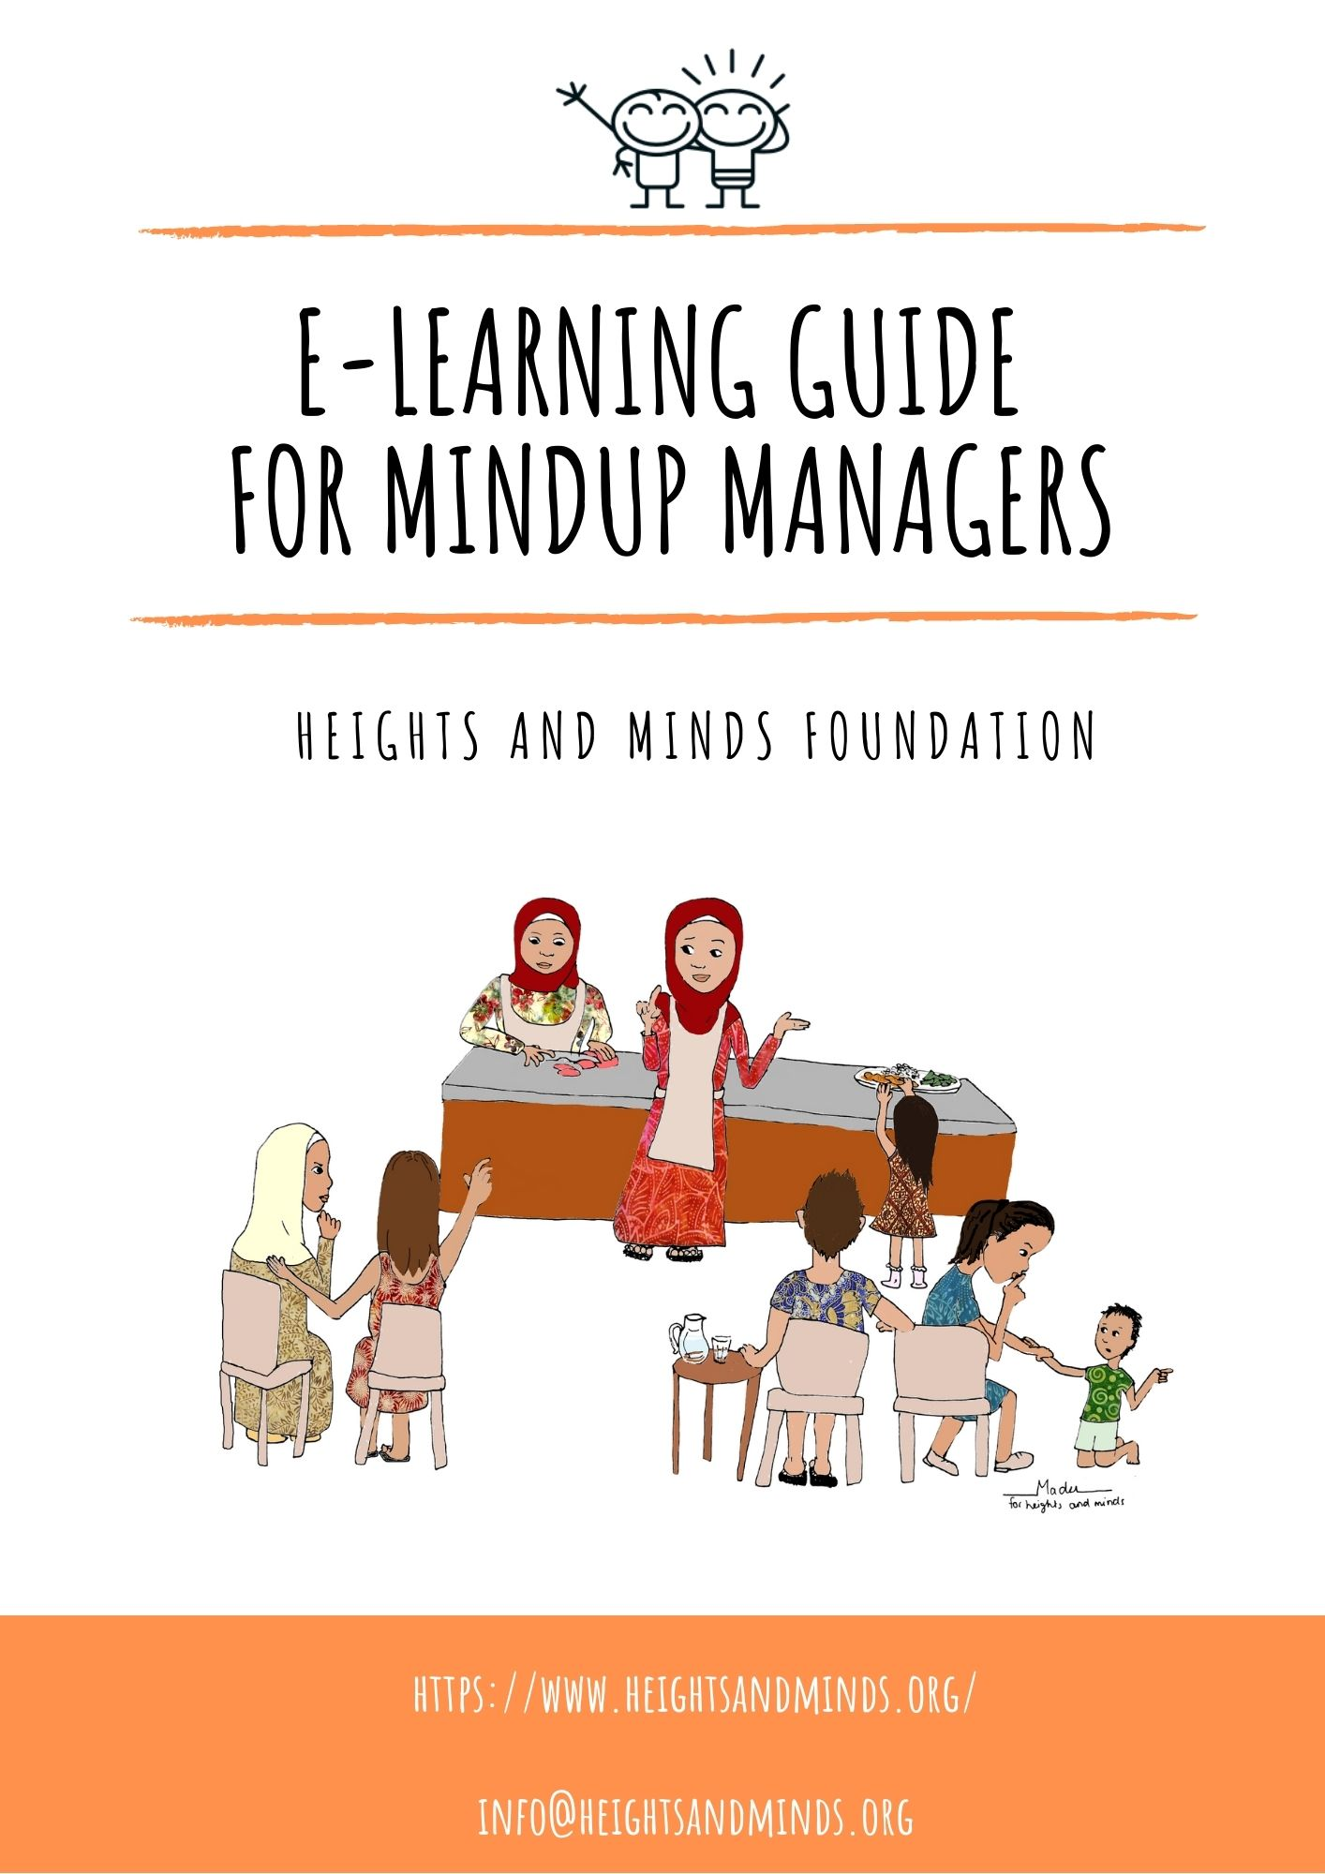

Table of content
1. Introduction 4
1.1 Why E-learning? 4
1.2 How does it work? 4
2. Methodology 5
2.1 How to use the E-learning modules 5
2.1.1 Adapting the E-learning modules to the local context and culture 5
2.1.2 Requirements of a MUM to start the E-learning training 7
2.2 Content E-learning modules 7
2.3 Sequence E-learning modules 9
2.4 Evaluation skills and knowledge E-learning modules 10
3. Media used in e-learning modules 11
3.1 Overview of GloCal videos used in e-learning modules 11
Appendix A: Example of different E-learning module levels and evaluation questions 12
Appendix B: Checklist E-learning modules 14
Appendix C: GloCal videos with links to YouTube 15

Abbreviations
CNDN Conseil National de Développement de la Nutrition
ECD Early Childhood Development
GMP Growth Monitoring and Promotion
MUM MindUp Manager
PPT PowerPoint
WHO World Health Organization
UNICEF United Nations Children’s Fund

Introduction
The Heights and Minds Foundation designed E-learning trainings specifically for MindUp-Managers (MUMs). This training includes technical, practical, and operational modules relevant to managing the MindUp’s services such as child growth promotion, advice concerning nutrition and a healthy diet, and basic management of a MindUp. All modules will be in E-learning mode and will be accompanied by brief assessments to verify skills and eventual certification. Practical skills, such as measuring children’s height correctly, will be assessed using video calling or on-site supervision visits. All Modules and guidance notes will be adapted to the local context during the preparation phase before a MindUp opens. This is done in partnership with the local partner.

Why E-learning?
The Heights and Minds proposes E-learning as it will be the principal interactive tool to communicate and engage with all MUMs globally and learn from each other. This dynamic environment is necessary to adapt to the local conditions, making sure the proposed methods are realistic, feasible, and efficient. Digital skills belong to the 21st century and we believe this method of learning will bring the MUMs up to speed with the latest technology, thus opening MUMs and MindUps access to the global community of practitioners in nutrition. Finally, E-learning and verification of skills will allow for rapid scaling up of the MindUps.

How does it work?
A MUM who is responsible for a Heights and Minds MindUp has access to the provided technology, materials, and tools at the MindUp and will be provided with an account with a password to access the E-learning modules. The local partner and Heights and Minds will provide continuous guidance to the MUMs either during face-to-face sessions and/or virtual sessions. MUMs will be required to complete the Heights and Minds modules at the beginning of their assignments (within the first months). Refresher modules and new or updated training sessions will be held regularly. All training sessions and completion of modules are mandatory. There will be clear guidelines on timing with each training.
The E-learning training module structure is based on the MUM’s responsibilities. MUMs are required to use the digital material provided. How to use the digitial materials and develop practical skills will be covered in the learning modules. In addition, modules to acquire managerial skills to run and manage the MindUp are tailor-made for each MindUp are also included in these E-learning trainings.
The responsibilities of the MUMs:
- Use of digital tools and materials
  - Completion of E-learning training modules to fulfill their role at the MindUp
  - Registration of new children (under the age of 2) and pregnant women into the Heights and Minds registry system
  - Starts a Heights and Minds first 1,000 days album for each new participant
  - Updates the child’s information in their MindUp file and in the first 1,000 days album
- Use of practical skills
  - Correctly complete anthropometrical measurements, including measuring children under the age of 2 using the length mat (every 3 months), weighing children using the salter scale (every month up to the age of 2), and measuring children’s arm circumference
  - Interpreting the anthropometrical measurements
  - Counseling mothers, parents and families on growth, nutrition, and parenting
- Daily management of the MindUp
  - Use of relevant basic managerial skills in running the MindUp
  - Financial monitoring, budgeting, and reporting
  - Entrepreneurship

Methodology
This chapter describes how the E-learning modules should be used, the content and sequence of the modules, and how to evaluate the MUMs skills and knowledge obtained by the E-learning modules.

How to use the E-learning modules
The E-learning modules are divided into 4 parts:
- Child Growth Monitoring and Promotion (GMP)
- Basic nutrition understanding
- Nutrition, Growth and Development during the first 1,000 days of life
- MindUp core management skills
The E-learning modules are available in the following languages: English, French, and Spanish and will be translated in local languages as part of the local adaptation.
These modules contain the essential skills and knowledge a MUM needs to obtain based on global guidelines from the World Health Organization (WHO) and United Nations Children’s Fund (UNICEF). Heights and Minds will update all technical modules on nutrition and Early Childhood Development (ECD) regularly, but at least once a year with relevant and new information. Annual (yearly) refresher training will be required but may be more often following important additions and updates.

2.1.1 Adapting the E-learning modules to the local context and culture
To adapt the E-learning modules to the local context and culture, Heights and Minds needs support from partner organizations in the host country of the MindUp. The adaptation will be done as part of the preparation phase during which the MindUp is being established and MUMs are selected.
Adapting the E-learning modules to the local context and culture requires:
(i) verifying the content of the e-learning modules with the national guidelines of the host country,
(ii) translating the content of the modules to the local language,
(iii) adapting examples of foods given in the modules to locally available and affordable foods, and
(iv) adjusting to certain cultural beliefs towards nutrition or health advice given in the E-learning modules.
In the E-learning modules text / pictures / videos / guidelines that can/should be adapted to the local context, are marked with an Asterix *. At the end of each E-learning module, specific guidance is included as to which text/video etc. requires local adaptation to the local context and whether it is a global nutrition guideline that can be adapted to the national nutrition guidelines, pictures with examples of foods, educative/explanatory videos. An example of this is given in figure 1.
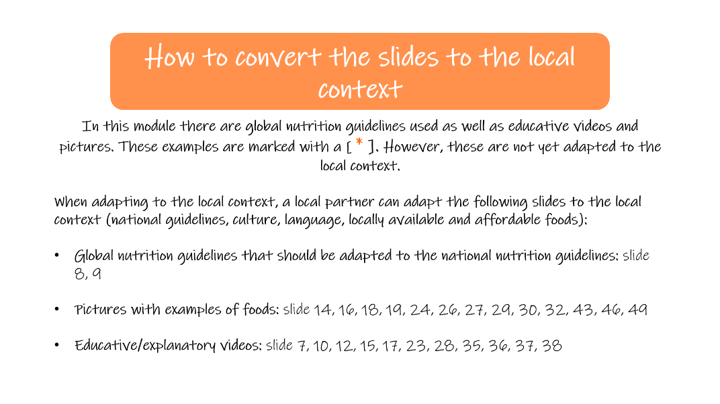
Figure 1 Example of an explanation on how to convert the slides to the local context at the end of the complementary feeding module.
Example of how to convert a slide to the local context
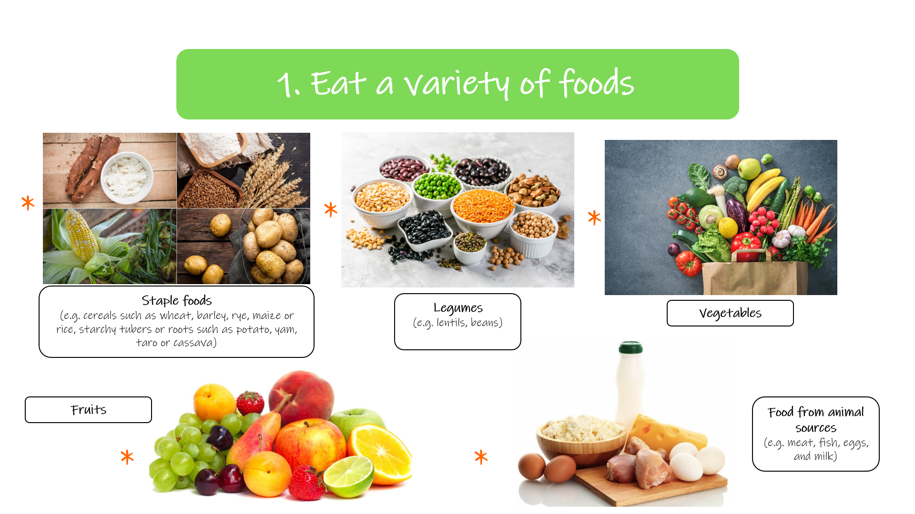

Figure 2 Example of a slide from the complementary feeding module that can be adapted to the local context by the local partner organization.
Figure 2 can be adapted to the local context by replacing the pictures of staple foods, legumes, vegetables, fruits, and animal foods by pictures of foods in these food groups that are locally available, affordable, and accessible. Examples can be written down in the description of the 5 different food groups.
When needed the text can be translated by the local partner organization to the local language of the host country of the Heights and Minds MindUp also.

2.1.2 Requirements of a MUM to start the E-learning training
After adapting the E-learning modules to the local context and culture, a MUM can take the E-learning training if they meets the following requirements:
- Willingness to learn and to engage
- Have access to Mobile phone number and/or e-mail address
- Basic computer skills and the ability to work with Microsoft Office (Word, Excel, and PowerPoint)
- Basic Understanding of English, French or Spanish is preferred

Content E-learning modules
The E-learning modules are divided into 4 themes and subdivided into different modules. The four themes include:
- Child growth monitoring and promotion
- Basic nutrition understanding
- Nutrition growth and development during the first 1,000 days of life
- MindUp core management skills
The module content within each theme is described in the following tables.
- A. Child Growth Monitoring and Promotion (GMP)
Themes | Modules | Materials
Child Growth Monitoring and Promotion | Module 1: Child growth monitoring and promotion (GMP) | E-learning module (PPT format) – includes the following subjects:  - Malnutrition  - Stunting  - First 1,000 days  - GMP (measurements, interpretation)  - Developmental milestones  Also includes an instruction video on how to perform anthropometrical measurements in French and Bahasa.

- B. Basic nutrition understanding
Themes | Modules | Materials
Basic nutrition understanding | Module 2: Healthy diet, macro- and micro-nutrients | E-learning module (PPT format) -  includes the following subjects:  - A healthy diet for pregnant women  - A healthy diet for adults  - A healthy diet for infants and young children  - Practical advice on maintaining a healthy diet throughout the life cycle  - Macronutrients: carbohydrates, proteins, fats  - Micronutrients: vitamins, minerals important for pregnant women / infants and young children (folate, iodine, iron, vitamin A, zinc)

- C. Nutrition, Growth and Development during the first 1,000 days of life
Themes | Modules | Materials
Nutrition growth and development during the first 1,000 days of life | Module 3.1: Breastfeeding | E-learning module (PPT format) - includes the following subjects:  - The basics of breastfeeding (benefits, exclusive breastfeeding, positions, frequency)  - The benefits of breastmilk over formula and animal milk  - Attachment to the breast  - Milk expression  - Storing breastmilk  - Breastfeeding problems  - HIV and breastfeeding
 | Module 3.2: Complementary Feeding | E-learning module (PPT format) - includes the following subjects:  - Good complementary foods  - The introduction of complementary foods  - (Complementary) feeding  - Snacks and finger foods  - Foods to avoid during the complementary feeding phase  - HIV and complementary feeding  - Keeping food safe and clean  - Developmental readiness for complementary foods  - Adverse reactions to food  - Establishing dietary variety and food preferences

- D. MindUp Core Management Skills
Themes | Modules | Materials
MindUp core management skills | Module 4.1: MindUp Management | -Drafting-  E-learning module (PPT format) -  includes the following subjects:  - Basic planning and budgeting  - Accounting and financial management  - Marketing
 | Module 4.2: Entrepreneurship | -Drafting-
 | Module 4.3: Other (environment, sustainability, etc.) | -Drafting-

Sequence E-learning modules
The sequence of the E-learning modules is viewed in figure 3.
When a MUM starts the E-learning training it is best to start with the modules on growth promotion which explain the different forms of malnutrition and the importance of monitoring child growth. After that a MUM can continue with the GMP module and the modules with regard to breastfeeding, complementary feeding, and first 1,000 days messages. These modules contain the key information needed to assist young mothers and mothers-to-be with monitoring the growth of their child and give the right advice. To get more basic nutrition understanding, the module about a healthy diet, macro- and micro-nutrients can be studied.
Lastly, the modules about MindUp management will provide a MUM all the essential knowledge and skills to run a MindUp.

Figure 3 Sequence E-learning modules
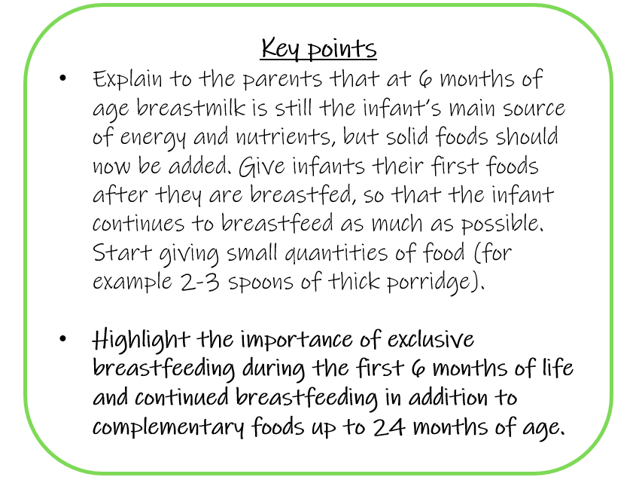
Basic, intermediate, advanced levels E-learning modules
Several E-learning modules consist of 3 different levels of knowledge: basic, intermediate, advanced². The modules with levels include child GMP, breastfeeding, complementary feeding, and a healthy diet: macro- and micro-nutrients. The aim is for a MUM to complete the three levels to provide all types of advice concerning a certain topic to the pregnant women and parents of infants and young children.
The MUM can continue to the next level when they can correctly answer all the questions from the checklist at the end of a level. To successfully finish the GMP module, it is also necessary that a MUM can correctly perform the anthropometrical measurements, interpret the outcomes, and register the data.
Key points
In order to have a clear link to the growth promotion messages, on various slides of the E-learning modules “Key points” are included to highlight what information should be shared with adolescents, pregnant women, and/or parents of infants and young children during the individual counselling sessions. Figure 4 provides an example. The Key points can also be adapted to the local context/culture by the local partner organization.
Figure 4 An example of Key points in the complementary feeding module
²See Appendix A: Example of different E-learning module levels and evaluation questions

Evaluation skills and knowledge E-learning modules
After taking the E-learning training a MUM should have basic skills and understanding of the following subjects:
- Child GMP
- Basic principles: breastfeeding, complementary feeding
- Practical skills: measuring children’s height (using the child length mat), children’s weight, and arm circumference
- Interpretation of anthropometric measurements and reporting
- Basic communication relevant to MindUp MUM counseling
- Basic nutrition understanding
- Maintaining a healthy diet throughout the life-cycle
- Macro- and micronutrients
- Hygiene and sanitation
- Food safety handling skills
- Nutrition, Growth and Development during the first 1,000 days of life
- Breastfeeding
- Complementary feeding
- MindUp core management skills
- Management (basic planning and budgeting, accounting and financial management, and marketing)
- Basically what you need to know to run a MindUp!
This will be evaluated by answering the evaluation questions at the end of each level of the different E-learning modules. A MUM should answer all the evaluation questions before continuing to the next level. Practical skills regarding Growth Monitoring and Promotion, individual counseling, and MindUp Management will be assessed via video recordings and/or assignments.
A MUM will receive a certificate when all of the modules are completed successfully, the checklist in appendix B will be used to track the progress.

Media used in e-learning modules
The majority of the videos that we use in our E-learning modules are made by Certa Nutritio³ (existing of a team of 4 researchers from the University of Helsinki, Finland). They are a small company specialized in Nutrition Education. Their focus is mainly on the nutrition and health of children, mothers and adolescents in low- and middle-income countries. The videos that they make are available on YouTube under the name “GloCal” but can also be downloaded, the content of these videos is adapted to the global guidelines of the WHO and UNICEF.

Overview of GloCal videos used in e-learning modules
There are various topics and themes that are covered in the GloCal videos including pregnancy, delivery, breastfeeding, complementary feeding, cognitive development, disease, nutrients and healthy foods, growth monitoring and promotion, hygiene, sexual health, and kitchen garden. Some of these videos are included in the Heights and Minds e-learning modules to support the content. The GloCal videos with the YouTube links can be found in Appendix C.
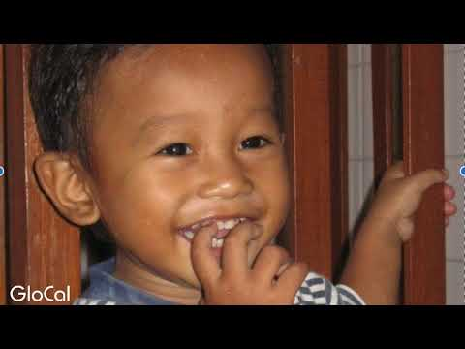
Figure 5 GloCal introduction video

³Website Certa Nutritio: https://www.certanutritio.com/
Website GloCal: http://www.glocalnutrition.com/

Appendix A: Example of different E-learning module levels and evaluation questions
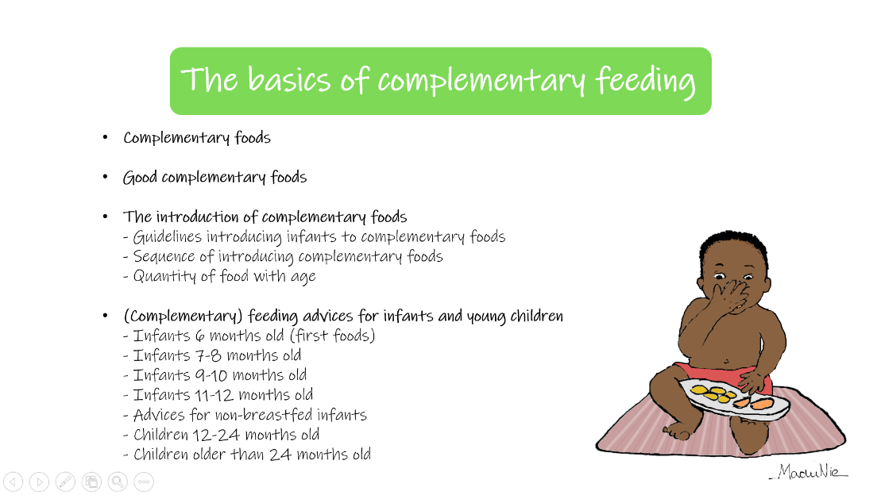
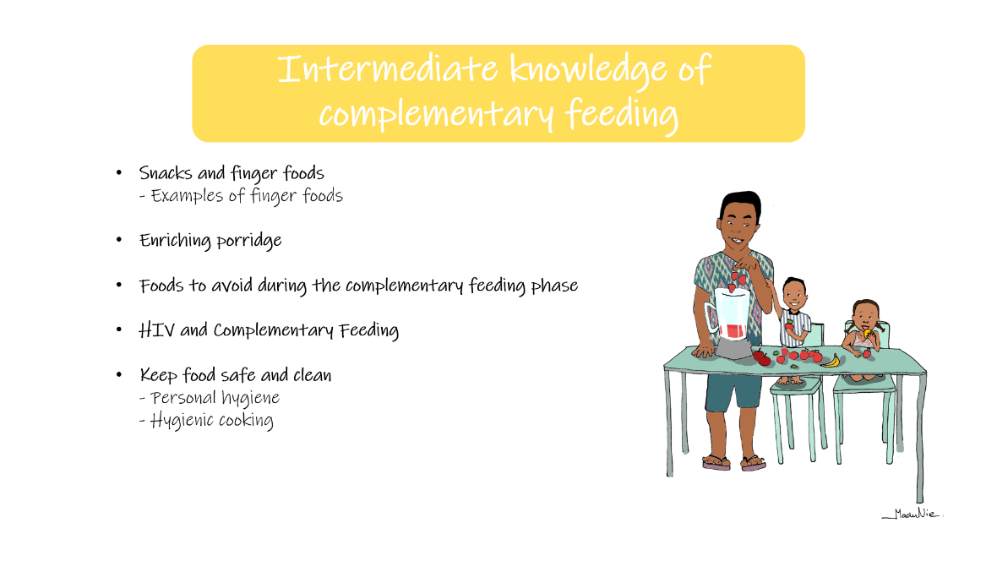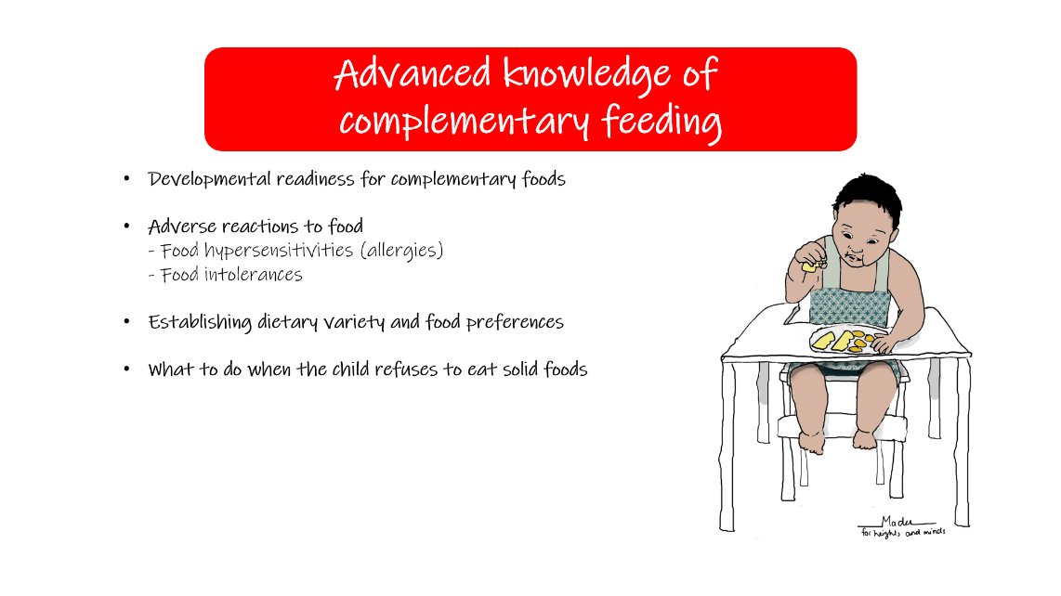
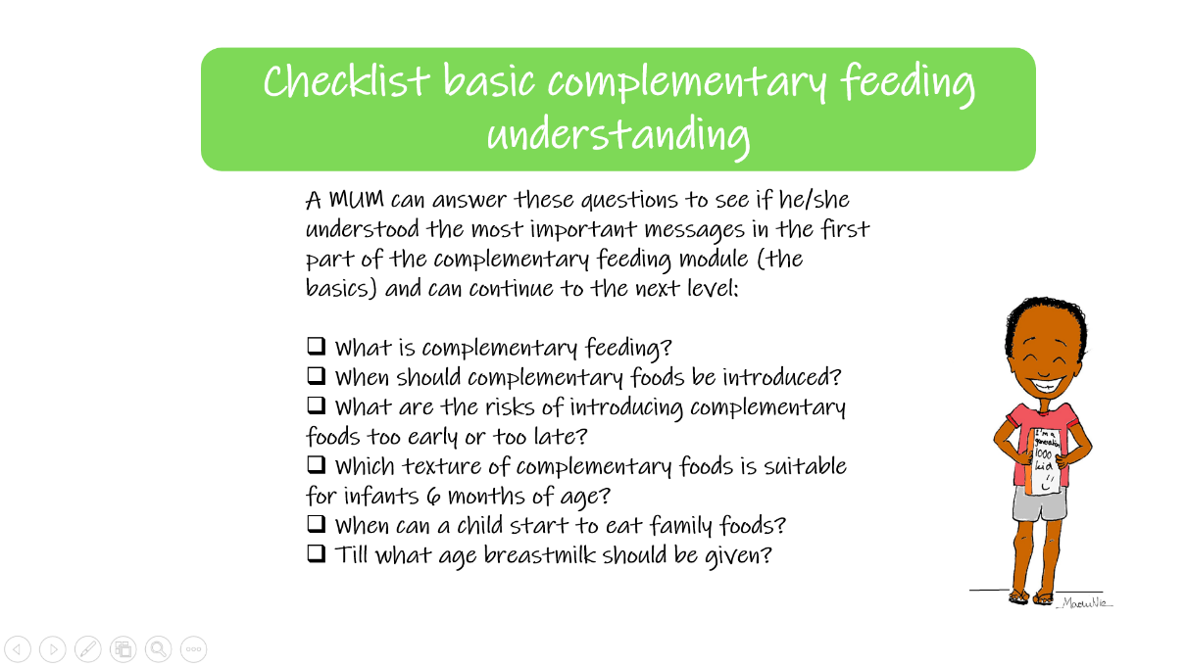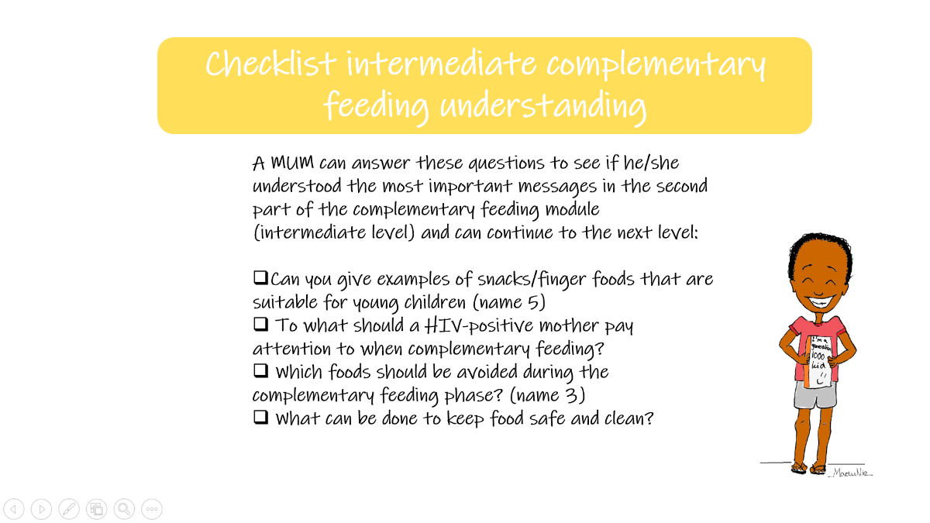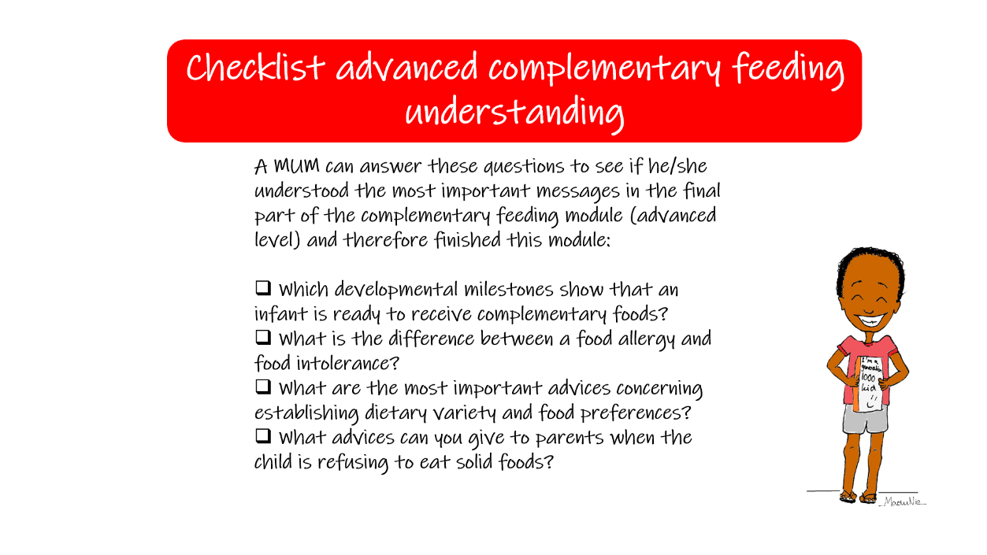

Appendix B: Checklist E-learning modules

Task | Level | Date of Completion
Initial Meeting with the Heights and Minds team
Module 1: Child Growth Monitoring and Promotion (GMP) | Level 1
 | Level 2
 | Level 3
 | Practical Skills
Module 2: Healthy diet, macro- and micro-nutrients | Level 1
 | Level 2
 | Level 3
 | Practical Skills
Module 3.1: Breastfeeding | Level 1
 | Level 2
 | Level 3
 | Practical Skills
Module 3.2: Complementary feeding | Level 1
 | Level 2
 | Level 3
 | Practical Skills
Module 4.1: MindUp Management | -Drafting-
Module 4.2: Entrepreneurship | -Drafting-
Module 4.3: Other (environment, sustainability, etc.) | -Drafting-

Appendix C: GloCal videos with links to YouTube
Video | English (African) | French | Wolof
- Quantity of food during pregnancy | https://www.youtube.com/watch?v=LVh6f-8frV0&list=PLOS5MMmDL-YdeY8gpi1Q8-bOqLOoHkYq_&index=31&ab_channel=CertaNutritio | https://www.youtube.com/watch?v=_c70ucP4iGU&list=PLOS5MMmDL-YcVnY1BEIeOxuyFSRr01fpc&index=34&ab_channel=CertaNutritio | https://www.youtube.com/watch?v=5Kcey6ji8gA&list=PLOS5MMmDL-YcDExF51kgu-YChnkV2a04C&index=45&ab_channel=CertaNutritio
- Weight gain during pregnancy | https://www.youtube.com/watch?v=mz5IiH5fK8E&list=PLOS5MMmDL-YdeY8gpi1Q8-bOqLOoHkYq_&index=42&ab_channel=CertaNutritio | https://www.youtube.com/watch?v=012_zQoqmFs&list=PLOS5MMmDL-YcVnY1BEIeOxuyFSRr01fpc&index=44&ab_channel=CertaNutritio | https://www.youtube.com/watch?v=pJfNI9swXu0&list=PLOS5MMmDL-YcDExF51kgu-YChnkV2a04C&index=61&ab_channel=CertaNutritio
- Theme: Pregnancy
- Theme: Delivery
Video | English (African) | French | Wolof
- Care after delivery | https://www.youtube.com/watch?v=SjK2fyk0ICA&list=PLOS5MMmDL-YdeY8gpi1Q8-bOqLOoHkYq_&index=5&ab_channel=CertaNutritio | https://www.youtube.com/watch?v=XbitbJSRjIw&list=PLOS5MMmDL-YcVnY1BEIeOxuyFSRr01fpc&index=5&ab_channel=CertaNutritio | https://www.youtube.com/watch?v=YiAK3WRX5dA&list=PLOS5MMmDL-YcDExF51kgu-YChnkV2a04C&index=13&ab_channel=CertaNutritio
- Delivering at health care facilities | https://www.youtube.com/watch?v=eU0pvf_WCy4&list=PLOS5MMmDL-YdeY8gpi1Q8-bOqLOoHkYq_&index=11&ab_channel=CertaNutritio | https://www.youtube.com/watch?v=UGnUQfRTrdo&list=PLOS5MMmDL-YcVnY1BEIeOxuyFSRr01fpc&index=12&ab_channel=CertaNutritio | https://www.youtube.com/watch?v=0NNFTmoMMA8&list=PLOS5MMmDL-YcDExF51kgu-YChnkV2a04C&index=20&ab_channel=CertaNutritio
- Vaccinations | https://www.youtube.com/watch?v=aSon8jMOV5w&list=PLOS5MMmDL-YdeY8gpi1Q8-bOqLOoHkYq_&index=40&ab_channel=CertaNutritio | https://www.youtube.com/watch?v=C3juc4aJFoo&list=PLOS5MMmDL-YcVnY1BEIeOxuyFSRr01fpc&index=42&ab_channel=CertaNutritio | https://www.youtube.com/watch?v=l_BZUzfJ0V8&list=PLOS5MMmDL-YcDExF51kgu-YChnkV2a04C&index=57&ab_channel=CertaNutritio
- Kangaroo care | https://www.youtube.com/watch?v=y7kgeZvhW5E&list=PLOS5MMmDL-YdeY8gpi1Q8-bOqLOoHkYq_&index=24&ab_channel=CertaNutritio | https://www.youtube.com/watch?v=NirUPgRYZT0&list=PLOS5MMmDL-YcVnY1BEIeOxuyFSRr01fpc&index=28&ab_channel=CertaNutritio | https://www.youtube.com/watch?v=Y2MZivuL1Lw&list=PLOS5MMmDL-YcDExF51kgu-YChnkV2a04C&index=38&ab_channel=CertaNutritio

- Theme: Breastfeeding
Video | English (African) | French | Wolof
- Breastfeeding benefits | https://www.youtube.com/watch?v=bhvNFPEjMig&list=PLOS5MMmDL-YdeY8gpi1Q8-bOqLOoHkYq_&index=2&ab_channel=CertaNutritio | https://www.youtube.com/watch?v=UQiDYaTUhwA&list=PLOS5MMmDL-YcVnY1BEIeOxuyFSRr01fpc&index=2&ab_channel=CertaNutritio | https://www.youtube.com/watch?v=SyLsKIh5vRM&list=PLOS5MMmDL-YcDExF51kgu-YChnkV2a04C&index=5&ab_channel=CertaNutritio
- Breastfeeding position | https://www.youtube.com/watch?v=g_94MLpyZHE&list=PLOS5MMmDL-YdeY8gpi1Q8-bOqLOoHkYq_&index=3&ab_channel=CertaNutritio | https://www.youtube.com/watch?v=iZ0VvpOsxaU&list=PLOS5MMmDL-YcVnY1BEIeOxuyFSRr01fpc&index=3&ab_channel=CertaNutritio | https://www.youtube.com/watch?v=a3Qk36Ykaw4&list=PLOS5MMmDL-YcDExF51kgu-YChnkV2a04C&index=7&ab_channel=CertaNutritio
- Breastmilk vs. Animal milk | https://www.youtube.com/watch?v=1kiE25BgmUY&list=PLOS5MMmDL-YdeY8gpi1Q8-bOqLOoHkYq_&index=4&ab_channel=CertaNutritio | https://www.youtube.com/watch?v=WJ-HQ3i5tXs&list=PLOS5MMmDL-YcVnY1BEIeOxuyFSRr01fpc&index=4&ab_channel=CertaNutritio | https://www.youtube.com/watch?v=cPfyx5OcesA&list=PLOS5MMmDL-YcDExF51kgu-YChnkV2a04C&index=10&ab_channel=CertaNutritio
- Colostrum | https://www.youtube.com/watch?v=2p5O_hlh1Dk&list=PLOS5MMmDL-YdeY8gpi1Q8-bOqLOoHkYq_&index=7&ab_channel=CertaNutritio | https://www.youtube.com/watch?v=jJSMIJrJKKQ&list=PLOS5MMmDL-YcVnY1BEIeOxuyFSRr01fpc&index=7&ab_channel=CertaNutritio | https://www.youtube.com/watch?v=47HjSsOBXDk&list=PLOS5MMmDL-YcDExF51kgu-YChnkV2a04C&index=15&ab_channel=CertaNutritio
- Exclusive breastfeeding | https://www.youtube.com/watch?v=96DNWtWKgPM&list=PLOS5MMmDL-YdeY8gpi1Q8-bOqLOoHkYq_&index=15&ab_channel=CertaNutritio | https://www.youtube.com/watch?v=bP_XOSRQgXg&list=PLOS5MMmDL-YcVnY1BEIeOxuyFSRr01fpc&index=16&ab_channel=CertaNutritio | https://www.youtube.com/watch?v=NnTnNA8dTnM&list=PLOS5MMmDL-YcDExF51kgu-YChnkV2a04C&index=25&ab_channel=CertaNutritio
- How often to breastfeed | https://www.youtube.com/watch?v=-iDhJv6Sqm0&list=PLOS5MMmDL-YdeY8gpi1Q8-bOqLOoHkYq_&index=20&ab_channel=CertaNutritio | https://www.youtube.com/watch?v=Fgv22I0mT_c&list=PLOS5MMmDL-YcVnY1BEIeOxuyFSRr01fpc&index=24&ab_channel=CertaNutritio | https://www.youtube.com/watch?v=q7TaS4MvopA&list=PLOS5MMmDL-YcDExF51kgu-YChnkV2a04C&index=32&ab_channel=CertaNutritio
- Milk expression | https://www.youtube.com/watch?v=_-eTnXlRrSo&list=PLOS5MMmDL-YdeY8gpi1Q8-bOqLOoHkYq_&index=26&ab_channel=CertaNutritio | https://www.youtube.com/watch?v=hVyKuc_yjHo&list=PLOS5MMmDL-YcVnY1BEIeOxuyFSRr01fpc&index=57&ab_channel=CertaNutritio | Not available
- Physiology of lactation | https://www.youtube.com/watch?v=jmI4g25eK8s&list=PLOS5MMmDL-YdeY8gpi1Q8-bOqLOoHkYq_&index=28&ab_channel=CertaNutritio | https://www.youtube.com/watch?v=EEh-vbL5B7E&list=PLOS5MMmDL-YcVnY1BEIeOxuyFSRr01fpc&index=31&ab_channel=CertaNutritio | https://www.youtube.com/watch?v=_8KU2xNk9nU&list=PLOS5MMmDL-YcDExF51kgu-YChnkV2a04C&index=41&ab_channel=CertaNutritio
- Sufficiency of breastmilk | https://www.youtube.com/watch?v=uXEodry8PqA&list=PLOS5MMmDL-YdeY8gpi1Q8-bOqLOoHkYq_&index=38&ab_channel=CertaNutritio | https://www.youtube.com/watch?v=K5RvzArnQJ8&list=PLOS5MMmDL-YcVnY1BEIeOxuyFSRr01fpc&index=40&ab_channel=CertaNutritio | https://www.youtube.com/watch?v=vEDz1zH0aew&list=PLOS5MMmDL-YcDExF51kgu-YChnkV2a04C&index=54&ab_channel=CertaNutritio
- Working mother | https://www.youtube.com/watch?v=HFG6ZvjQ8Sw&list=PLOS5MMmDL-YdeY8gpi1Q8-bOqLOoHkYq_&index=45&ab_channel=CertaNutritio | https://www.youtube.com/watch?v=QuarMyuWo0Y&list=PLOS5MMmDL-YcVnY1BEIeOxuyFSRr01fpc&index=47&ab_channel=CertaNutritio | https://www.youtube.com/watch?v=3e4DJq5ochw&list=PLOS5MMmDL-YcDExF51kgu-YChnkV2a04C&index=65&ab_channel=CertaNutritio
- HIV and breastfeeding | https://www.youtube.com/watch?v=KXO6Gco9JSc&list=PLOS5MMmDL-YdeY8gpi1Q8-bOqLOoHkYq_&index=49&ab_channel=CertaNutritio | https://www.youtube.com/watch?v=CwqDuy5UwpE&list=PLOS5MMmDL-YcVnY1BEIeOxuyFSRr01fpc&index=22&ab_channel=CertaNutritio | Not available
- Breastfeeding problems | https://www.youtube.com/watch?v=dPpPVtO1pGU&list=PLOS5MMmDL-YdeY8gpi1Q8-bOqLOoHkYq_&index=64&ab_channel=CertaNutritio | https://www.youtube.com/watch?v=Sd6tWga36rk&list=PLOS5MMmDL-YcVnY1BEIeOxuyFSRr01fpc&index=21&ab_channel=CertaNutritio | https://www.youtube.com/watch?v=E15CsFcWCzE&list=PLOS5MMmDL-YcDExF51kgu-YChnkV2a04C&index=9&ab_channel=CertaNutritio

- Theme: Complementary feeding (CF)
Video | English (African) | French | Wolof
- Starting CF | https://www.youtube.com/watch?v=4vE5h5dLbh4&list=PLOS5MMmDL-YdeY8gpi1Q8-bOqLOoHkYq_&index=36&ab_channel=CertaNutritio | https://www.youtube.com/watch?v=8Hc9gl-iZDo&list=PLOS5MMmDL-YcVnY1BEIeOxuyFSRr01fpc&index=38&ab_channel=CertaNutritio | https://www.youtube.com/watch?v=LJ2sSs8HnrA&list=PLOS5MMmDL-YcDExF51kgu-YChnkV2a04C&index=52&ab_channel=CertaNutritio
- CF at 7-8 months | https://www.youtube.com/watch?v=opS1SMSlpZg&list=PLOS5MMmDL-YdeY8gpi1Q8-bOqLOoHkYq_&index=9&ab_channel=CertaNutritio | https://www.youtube.com/watch?v=exMEAfD7XGg&list=PLOS5MMmDL-YcVnY1BEIeOxuyFSRr01fpc&index=8&ab_channel=CertaNutritio | https://www.youtube.com/watch?v=HtI8vlA6suY&list=PLOS5MMmDL-YcDExF51kgu-YChnkV2a04C&index=16&ab_channel=CertaNutritio
- CF at 9-11 months | https://www.youtube.com/watch?v=l-L0HCfKVgA&list=PLOS5MMmDL-YdeY8gpi1Q8-bOqLOoHkYq_&index=50&ab_channel=CertaNutritio | https://www.youtube.com/watch?v=JqJwT5IjCIU&list=PLOS5MMmDL-YcVnY1BEIeOxuyFSRr01fpc&index=9&ab_channel=CertaNutritio | https://www.youtube.com/watch?v=_HXd3kQCiIw&list=PLOS5MMmDL-YcDExF51kgu-YChnkV2a04C&index=17&ab_channel=CertaNutritio
- CF at 1-2 years | https://www.youtube.com/watch?v=GhdR9qd2brk&list=PLOS5MMmDL-YdeY8gpi1Q8-bOqLOoHkYq_&index=10&ab_channel=CertaNutritio | https://www.youtube.com/watch?v=XwHua8OJ8Mg&list=PLOS5MMmDL-YcVnY1BEIeOxuyFSRr01fpc&index=10&ab_channel=CertaNutritio | https://www.youtube.com/watch?v=FhkxEIWtA8A&list=PLOS5MMmDL-YcDExF51kgu-YChnkV2a04C&index=18&ab_channel=CertaNutritio
- CF from family foods | https://www.youtube.com/watch?v=Nx_erOrTbuk&list=PLOS5MMmDL-YdeY8gpi1Q8-bOqLOoHkYq_&index=8&ab_channel=CertaNutritio | https://www.youtube.com/watch?v=LCGl4UCN_4Y&list=PLOS5MMmDL-YcVnY1BEIeOxuyFSRr01fpc&index=11&ab_channel=CertaNutritio | https://www.youtube.com/watch?v=KcK8NaNbpe4&list=PLOS5MMmDL-YcDExF51kgu-YChnkV2a04C&index=19&ab_channel=CertaNutritio
- HIV and complementary feeding | https://www.youtube.com/watch?v=YNyUKaztvDk&list=PLOS5MMmDL-YdeY8gpi1Q8-bOqLOoHkYq_&index=19&ab_channel=CertaNutritio | https://www.youtube.com/watch?v=lNrh-3NraNo&list=PLOS5MMmDL-YcVnY1BEIeOxuyFSRr01fpc&index=23&ab_channel=CertaNutritio | https://www.youtube.com/watch?v=VtrsbjTO-_I&list=PLOS5MMmDL-YcDExF51kgu-YChnkV2a04C&index=31&ab_channel=CertaNutritio
- Quantity of food with age | https://www.youtube.com/watch?v=ZUUszs2NUJc&list=PLOS5MMmDL-YdeY8gpi1Q8-bOqLOoHkYq_&index=32&ab_channel=CertaNutritio | https://www.youtube.com/watch?v=ROCEQQbg2jE&list=PLOS5MMmDL-YcVnY1BEIeOxuyFSRr01fpc&index=35&ab_channel=CertaNutritio | https://www.youtube.com/watch?v=K69M3gJxWec&list=PLOS5MMmDL-YcDExF51kgu-YChnkV2a04C&index=47&ab_channel=CertaNutritio
- Snacks and finger foods | https://www.youtube.com/watch?v=av_mZ2HwJP4&list=PLOS5MMmDL-YdeY8gpi1Q8-bOqLOoHkYq_&index=34&ab_channel=CertaNutritio | https://www.youtube.com/watch?v=xrI7lKH3egA&list=PLOS5MMmDL-YcVnY1BEIeOxuyFSRr01fpc&index=37&ab_channel=CertaNutritio | https://www.youtube.com/watch?v=8hTOrUoMq8k&list=PLOS5MMmDL-YcDExF51kgu-YChnkV2a04C&index=50&ab_channel=CertaNutritio

- Theme: Cognitive development
Video | English (African) | French | Wolof
- Cognitive development | https://www.youtube.com/watch?v=k6BTyq14Fng&list=PLOS5MMmDL-YdeY8gpi1Q8-bOqLOoHkYq_&index=6&ab_channel=CertaNutritio | https://www.youtube.com/watch?v=Evb_9G67-d4&list=PLOS5MMmDL-YcVnY1BEIeOxuyFSRr01fpc&index=6&ab_channel=CertaNutritio | https://www.youtube.com/watch?v=q0TyYzv2hzk&list=PLOS5MMmDL-YcDExF51kgu-YChnkV2a04C&index=14&ab_channel=CertaNutritio
- What about dad | https://www.youtube.com/watch?v=_ev7ELaSauA&list=PLOS5MMmDL-YdeY8gpi1Q8-bOqLOoHkYq_&index=43&ab_channel=CertaNutritio | https://www.youtube.com/watch?v=ZSUnkY0sOZE&list=PLOS5MMmDL-YcVnY1BEIeOxuyFSRr01fpc&index=45&ab_channel=CertaNutritio | https://www.youtube.com/watch?v=bj3HkeB-moE&list=PLOS5MMmDL-YcDExF51kgu-YChnkV2a04C&index=63&ab_channel=CertaNutritio

- Theme: Disease
Video | English (African) | French | Wolof
- Diarrhea | https://www.youtube.com/watch?v=ZGQ0-AXVtqU&list=PLOS5MMmDL-YdeY8gpi1Q8-bOqLOoHkYq_&index=13&ab_channel=CertaNutritio | https://www.youtube.com/watch?v=YOqgOV_7-fw&list=PLOS5MMmDL-YcVnY1BEIeOxuyFSRr01fpc&index=14&ab_channel=CertaNutritio | https://www.youtube.com/watch?v=KS_-QoeHEAw&list=PLOS5MMmDL-YcDExF51kgu-YChnkV2a04C&index=23&ab_channel=CertaNutritio
- Diabetes | https://www.youtube.com/watch?v=UoU92wSdi3A&list=PLOS5MMmDL-YdeY8gpi1Q8-bOqLOoHkYq_&index=12&ab_channel=CertaNutritio | https://www.youtube.com/watch?v=wudlGGE7dzI&list=PLOS5MMmDL-YcVnY1BEIeOxuyFSRr01fpc&index=13&ab_channel=CertaNutritio | https://www.youtube.com/watch?v=bZyQ3oYLKAE&list=PLOS5MMmDL-YcDExF51kgu-YChnkV2a04C&index=21&ab_channel=CertaNutritio
- Malaria | https://www.youtube.com/watch?v=jdEiSuAzSZY&list=PLOS5MMmDL-YdeY8gpi1Q8-bOqLOoHkYq_&index=25&ab_channel=CertaNutritio | https://www.youtube.com/watch?v=XTOaolMmkOs&list=PLOS5MMmDL-YcVnY1BEIeOxuyFSRr01fpc&index=29&ab_channel=CertaNutritio | https://www.youtube.com/watch?v=uqBuLB1Zlxs&list=PLOS5MMmDL-YcDExF51kgu-YChnkV2a04C&index=39&ab_channel=CertaNutritio
- Anemia | https://www.youtube.com/watch?v=j0y2fGRd07w&list=PLOS5MMmDL-YdeY8gpi1Q8-bOqLOoHkYq_&index=1&ab_channel=CertaNutritio | https://www.youtube.com/watch?v=eHQ8VMEmuWU&list=PLOS5MMmDL-YcVnY1BEIeOxuyFSRr01fpc&ab_channel=CertaNutritio | https://www.youtube.com/watch?v=F5p1hYIgQoI&list=PLOS5MMmDL-YcDExF51kgu-YChnkV2a04C&index=4&ab_channel=CertaNutritio
- Prevention of Anemia | https://www.youtube.com/watch?v=ms8r_rlawwc&list=PLOS5MMmDL-YdeY8gpi1Q8-bOqLOoHkYq_&index=29&ab_channel=CertaNutritio | https://www.youtube.com/watch?v=aoImw-9iohY&list=PLOS5MMmDL-YcVnY1BEIeOxuyFSRr01fpc&index=32&ab_channel=CertaNutritio | https://www.youtube.com/watch?v=5cgqSn1Kge0&list=PLOS5MMmDL-YcDExF51kgu-YChnkV2a04C&index=42&ab_channel=CertaNutritio
- What does HIV do | https://www.youtube.com/watch?v=ZBxFEmMhB_w&list=PLOS5MMmDL-YdeY8gpi1Q8-bOqLOoHkYq_&index=44&ab_channel=CertaNutritio | https://www.youtube.com/watch?v=uFgd2qRyuOo&list=PLOS5MMmDL-YcVnY1BEIeOxuyFSRr01fpc&index=46&ab_channel=CertaNutritio | https://www.youtube.com/watch?v=5cgqSn1Kge0&list=PLOS5MMmDL-YcDExF51kgu-YChnkV2a04C&index=42&ab_channel=CertaNutritio
- Worms | https://www.youtube.com/watch?v=Hy6FiFZ8R1g&list=PLOS5MMmDL-YdeY8gpi1Q8-bOqLOoHkYq_&index=46&ab_channel=CertaNutritio | https://www.youtube.com/watch?v=dTtsG56q6Yk&list=PLOS5MMmDL-YcVnY1BEIeOxuyFSRr01fpc&index=49&ab_channel=CertaNutritio | https://www.youtube.com/watch?v=9oP4ESX9PZ0&list=PLOS5MMmDL-YcDExF51kgu-YChnkV2a04C&index=66&ab_channel=CertaNutritio
- Corona | https://www.youtube.com/watch?v=Jyhii-I1FJY&list=PLOS5MMmDL-YdeY8gpi1Q8-bOqLOoHkYq_&index=66&ab_channel=CertaNutritio | https://www.youtube.com/watch?v=nC8e-6oU7Ho&list=PLOS5MMmDL-YcVnY1BEIeOxuyFSRr01fpc&index=50&ab_channel=CertaNutritio | Not available

- Theme: Nutrients and healthy foods
Video | English (African) | French | Wolof
- Folate | https://www.youtube.com/watch?v=7k0jpMuLHAk&list=PLOS5MMmDL-YdeY8gpi1Q8-bOqLOoHkYq_&index=16&ab_channel=CertaNutritio | https://www.youtube.com/watch?v=XCPMEfUnXp8&list=PLOS5MMmDL-YcVnY1BEIeOxuyFSRr01fpc&index=18&ab_channel=CertaNutritio | https://www.youtube.com/watch?v=lehtntJAHug&list=PLOS5MMmDL-YcDExF51kgu-YChnkV2a04C&index=27&ab_channel=CertaNutritio
- Food groups | https://www.youtube.com/watch?v=GL1I7c8oHCw&list=PLOS5MMmDL-YdeY8gpi1Q8-bOqLOoHkYq_&index=17&ab_channel=CertaNutritio | https://www.youtube.com/watch?v=TSzbPRTE5eQ&list=PLOS5MMmDL-YcVnY1BEIeOxuyFSRr01fpc&index=19&ab_channel=CertaNutritio | https://www.youtube.com/watch?v=ztnoBHIsdNk&list=PLOS5MMmDL-YcDExF51kgu-YChnkV2a04C&index=55&ab_channel=CertaNutritio
- Iodine | https://www.youtube.com/watch?v=CJyURHrf2Qg&list=PLOS5MMmDL-YdeY8gpi1Q8-bOqLOoHkYq_&index=23&ab_channel=CertaNutritio | https://www.youtube.com/watch?v=rrePYkbUgZY&list=PLOS5MMmDL-YcVnY1BEIeOxuyFSRr01fpc&index=27&ab_channel=CertaNutritio | https://www.youtube.com/watch?v=Y_dRZpOr-7E&list=PLOS5MMmDL-YcDExF51kgu-YChnkV2a04C&index=37&ab_channel=CertaNutritio
- Minimum Dietary Diversity | https://www.youtube.com/watch?v=Pa2xV1S_yt8&list=PLOS5MMmDL-YdeY8gpi1Q8-bOqLOoHkYq_&index=27&ab_channel=CertaNutritio | https://www.youtube.com/watch?v=1h47ZBq4ZC4&list=PLOS5MMmDL-YcVnY1BEIeOxuyFSRr01fpc&index=30&ab_channel=CertaNutritio | https://www.youtube.com/watch?v=zKE8CMUrFCY&list=PLOS5MMmDL-YcDExF51kgu-YChnkV2a04C&index=40&ab_channel=CertaNutritio
- Proteins | https://www.youtube.com/watch?v=g-M_AmoYsZA&list=PLOS5MMmDL-YdeY8gpi1Q8-bOqLOoHkYq_&index=30&ab_channel=CertaNutritio | https://www.youtube.com/watch?v=fXR6hPtBqWo&list=PLOS5MMmDL-YcVnY1BEIeOxuyFSRr01fpc&index=33&ab_channel=CertaNutritio | https://www.youtube.com/watch?v=ix8eO7ipBE0&list=PLOS5MMmDL-YcDExF51kgu-YChnkV2a04C&index=44&ab_channel=CertaNutritio
- Replacing sugary foods with fruits | https://www.youtube.com/watch?v=iLL7nCh5vMY&list=PLOS5MMmDL-YdeY8gpi1Q8-bOqLOoHkYq_&index=33&ab_channel=CertaNutritio | https://www.youtube.com/watch?v=aIsmovkEG_8&list=PLOS5MMmDL-YcVnY1BEIeOxuyFSRr01fpc&index=36&ab_channel=CertaNutritio | https://www.youtube.com/watch?v=z_5J3G3qqwU&list=PLOS5MMmDL-YcDExF51kgu-YChnkV2a04C&index=49&ab_channel=CertaNutritio
- Sources of iron | https://www.youtube.com/watch?v=q67Gpn9S5ns&list=PLOS5MMmDL-YdeY8gpi1Q8-bOqLOoHkYq_&index=35&ab_channel=CertaNutritio | Not available | https://www.youtube.com/watch?v=8D9K5TpXro0&list=PLOS5MMmDL-YcDExF51kgu-YChnkV2a04C&index=51&ab_channel=CertaNutritio
- The 7 food groups for children | https://www.youtube.com/watch?v=jQf8K-xH9cQ&list=PLOS5MMmDL-YdeY8gpi1Q8-bOqLOoHkYq_&index=39&ab_channel=CertaNutritio | https://www.youtube.com/watch?v=ahK90g02cQ8&list=PLOS5MMmDL-YcVnY1BEIeOxuyFSRr01fpc&index=41&ab_channel=CertaNutritio | https://www.youtube.com/watch?v=w0mDAxixvCs&list=PLOS5MMmDL-YcDExF51kgu-YChnkV2a04C&index=29&ab_channel=CertaNutritio
- Vitamin A | https://www.youtube.com/watch?v=uLNnYjl5xIQ&list=PLOS5MMmDL-YdeY8gpi1Q8-bOqLOoHkYq_&index=41&ab_channel=CertaNutritio | https://www.youtube.com/watch?v=kRAWwJrZl-8&list=PLOS5MMmDL-YcVnY1BEIeOxuyFSRr01fpc&index=43&ab_channel=CertaNutritio | https://www.youtube.com/watch?v=wd-JZuKm-xk&list=PLOS5MMmDL-YcDExF51kgu-YChnkV2a04C&index=58&ab_channel=CertaNutritio
- Enriched porridge | https://www.youtube.com/watch?v=MSi6DPSQcBk&list=PLOS5MMmDL-YdeY8gpi1Q8-bOqLOoHkYq_&index=14&ab_channel=CertaNutritio | https://www.youtube.com/watch?v=9mkPYSWMv6Q&list=PLOS5MMmDL-YcVnY1BEIeOxuyFSRr01fpc&index=15&ab_channel=CertaNutritio | https://www.youtube.com/watch?v=xaLCXkKelsE&list=PLOS5MMmDL-YcDExF51kgu-YChnkV2a04C&index=24&ab_channel=CertaNutritio

- Theme: Growth monitoring and promotion
Video | English (African) | French | Wolof
- Growth monitoring | https://www.youtube.com/watch?v=ranFN4t-SRc&list=PLOS5MMmDL-YdeY8gpi1Q8-bOqLOoHkYq_&index=18&ab_channel=CertaNutritio | https://www.youtube.com/watch?v=DdHQKofG-Hw&list=PLOS5MMmDL-YcVnY1BEIeOxuyFSRr01fpc&index=20&ab_channel=CertaNutritio | https://www.youtube.com/watch?v=PNS8syOA0cU&list=PLOS5MMmDL-YcDExF51kgu-YChnkV2a04C&index=30&ab_channel=CertaNutritio
- Stunting | https://www.youtube.com/watch?v=OTrUrQ9Yj_0&list=PLOS5MMmDL-YdeY8gpi1Q8-bOqLOoHkYq_&index=37&ab_channel=CertaNutritio | https://www.youtube.com/watch?v=u8sTIo1rlPU&list=PLOS5MMmDL-YcVnY1BEIeOxuyFSRr01fpc&index=39&ab_channel=CertaNutritio | https://www.youtube.com/watch?v=6pwLmOBPI2E&list=PLOS5MMmDL-YcDExF51kgu-YChnkV2a04C&index=53&ab_channel=CertaNutritio

- Theme: Hygiene
Video | English (African) | French | Wolof
- Hygiene | https://www.youtube.com/watch?v=Jjp8FAeDJFw&list=PLOS5MMmDL-YdeY8gpi1Q8-bOqLOoHkYq_&index=21&ab_channel=CertaNutritio | https://www.youtube.com/watch?v=ePX9EMlszHg&list=PLOS5MMmDL-YcVnY1BEIeOxuyFSRr01fpc&index=25&ab_channel=CertaNutritio | https://www.youtube.com/watch?v=vaun_fWJ9Lc&list=PLOS5MMmDL-YcDExF51kgu-YChnkV2a04C&index=33&ab_channel=CertaNutritio
- Hygienic cooking | https://www.youtube.com/watch?v=j9zu24ZnLho&list=PLOS5MMmDL-YdeY8gpi1Q8-bOqLOoHkYq_&index=22&ab_channel=CertaNutritio | https://www.youtube.com/watch?v=ybUpWn58PmU&list=PLOS5MMmDL-YcVnY1BEIeOxuyFSRr01fpc&index=26&ab_channel=CertaNutritio | https://www.youtube.com/watch?v=t5_NvtIes3Y&list=PLOS5MMmDL-YcDExF51kgu-YChnkV2a04C&index=34&ab_channel=CertaNutritio

- Theme: Sexual health
Video | English (African) | French | Wolof
- Friendship and love | https://www.youtube.com/watch?v=leEoCCYR7mM&list=PLOS5MMmDL-YdeY8gpi1Q8-bOqLOoHkYq_&index=51&ab_channel=CertaNutritio | Not available in French | Not available in Wolof
- You have the right to rule over your body | https://www.youtube.com/watch?v=jz_hyTvFgGg&list=PLOS5MMmDL-YdeY8gpi1Q8-bOqLOoHkYq_&index=52&ab_channel=CertaNutritio
- The right to choose your partner | https://www.youtube.com/watch?v=YD5uK1nhHNw&list=PLOS5MMmDL-YdeY8gpi1Q8-bOqLOoHkYq_&index=53&ab_channel=CertaNutritio
- Communication | https://www.youtube.com/watch?v=ldISxHo9JGI&list=PLOS5MMmDL-YdeY8gpi1Q8-bOqLOoHkYq_&index=54&ab_channel=CertaNutritio
- When puberty hits | https://www.youtube.com/watch?v=Bha-HUIKcvc&list=PLOS5MMmDL-YdeY8gpi1Q8-bOqLOoHkYq_&index=55&ab_channel=CertaNutritio
- Menstrual hygiene | https://www.youtube.com/watch?v=NhNRR9dXNmg&list=PLOS5MMmDL-YdeY8gpi1Q8-bOqLOoHkYq_&index=56&ab_channel=CertaNutritio
- Marriage is for adults | https://www.youtube.com/watch?v=LUrFX3SgQ24&list=PLOS5MMmDL-YdeY8gpi1Q8-bOqLOoHkYq_&index=57&ab_channel=CertaNutritio
- How to prevent getting pregnant | https://www.youtube.com/watch?v=UQC6_KXYO9k&list=PLOS5MMmDL-YdeY8gpi1Q8-bOqLOoHkYq_&index=58&ab_channel=CertaNutritio
- Sexual transmitted infection | https://www.youtube.com/watch?v=NfpBs0GFXe4&list=PLOS5MMmDL-YdeY8gpi1Q8-bOqLOoHkYq_&index=59&ab_channel=CertaNutritio
- How many children | https://www.youtube.com/watch?v=Fswi-ZOe4EE&list=PLOS5MMmDL-YdeY8gpi1Q8-bOqLOoHkYq_&index=65&ab_channel=CertaNutritio

- Theme: Kitchen garden
Video | English (African) | French | Wolof
- Planning | https://www.youtube.com/watch?v=jZbSuiBOqjA&list=PLOS5MMmDL-YdeY8gpi1Q8-bOqLOoHkYq_&index=60&ab_channel=CertaNutritio | https://www.youtube.com/watch?v=6xAuCuoPeB0&list=PLOS5MMmDL-YcVnY1BEIeOxuyFSRr01fpc&index=51&ab_channel=CertaNutritio | https://www.youtube.com/watch?v=wpqloWBDn_Y&list=PLOS5MMmDL-YcDExF51kgu-YChnkV2a04C&index=1&ab_channel=CertaNutritio
- Preparing your garden | https://www.youtube.com/watch?v=I9KV7wRQlq0&list=PLOS5MMmDL-YdeY8gpi1Q8-bOqLOoHkYq_&index=61&ab_channel=CertaNutritio | https://www.youtube.com/watch?v=2Y2UWWlYcWg&list=PLOS5MMmDL-YcVnY1BEIeOxuyFSRr01fpc&index=52&ab_channel=CertaNutritio | Not available
- Planting | https://www.youtube.com/watch?v=1kQxM_czRWk&list=PLOS5MMmDL-YdeY8gpi1Q8-bOqLOoHkYq_&index=62&ab_channel=CertaNutritio | https://www.youtube.com/watch?v=9gHETA-mUko&list=PLOS5MMmDL-YcVnY1BEIeOxuyFSRr01fpc&index=54&ab_channel=CertaNutritio | https://www.youtube.com/watch?v=lsg0FZp-IDQ&list=PLOS5MMmDL-YcDExF51kgu-YChnkV2a04C&index=2&ab_channel=CertaNutritio
- Taking care of your plants | https://www.youtube.com/watch?v=62vrWM98Hdg&list=PLOS5MMmDL-YdeY8gpi1Q8-bOqLOoHkYq_&index=63&ab_channel=CertaNutritio | https://www.youtube.com/watch?v=aEwg4wr7bOM&list=PLOS5MMmDL-YcVnY1BEIeOxuyFSRr01fpc&index=55&ab_channel=CertaNutritio | https://www.youtube.com/watch?v=Agqext6VfG0&list=PLOS5MMmDL-YcDExF51kgu-YChnkV2a04C&index=3&ab_channel=CertaNutritio

